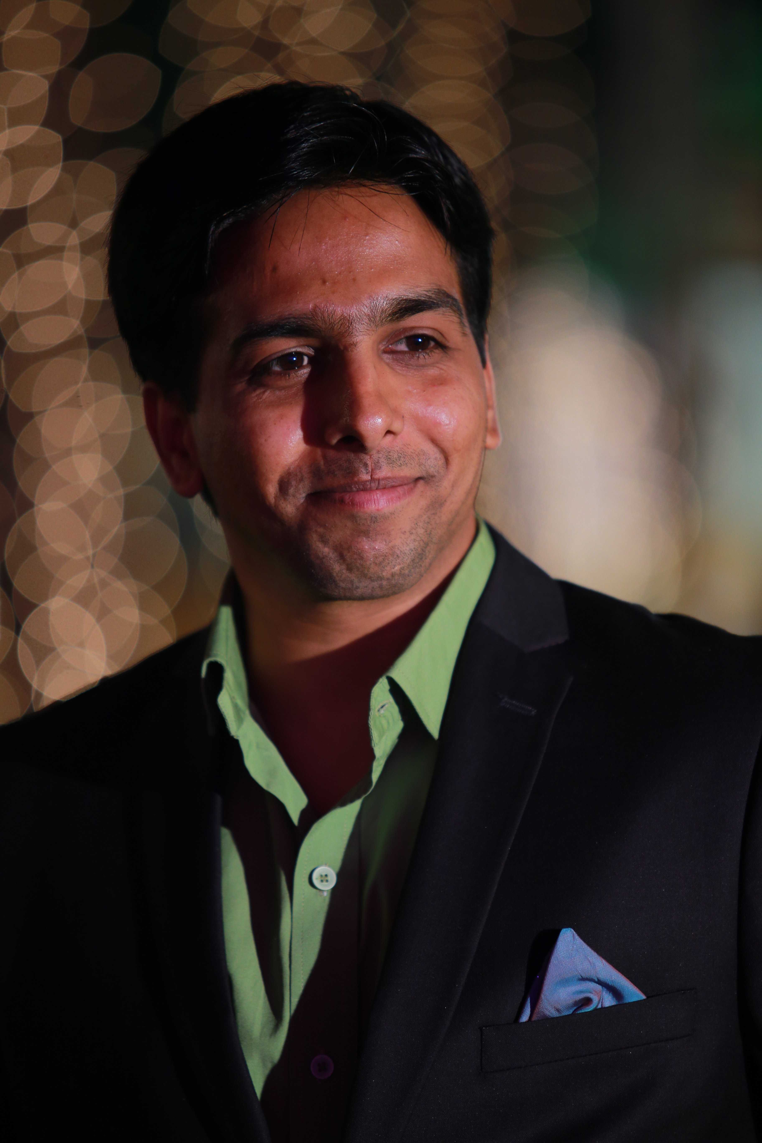

Yethin
Yethin.360208@2freemail.com

I am an accomplished Specialist Continental Chef, fully acclimatized with hands on experience. My passion is to cook and serve the best, for I believe, “The way to a man’s heart is through his stomach” So be it through my hands.

I am an effective Communicator, Self-confident, Quick- learner, Team player always aiming to achieving goals set.

Educational Background:

- (Month Year) - Post Graduate Diploma in Business Management from London School of
Business, London.

- September 2008 – Bachelors in Hotel Management from Joginpally Bhaskara Institute of
Hotel Management (affiliated to Osmania University), Hyderabad.

Training & Certifications:

- Jan 2007 till April 2007 - I have undergone an exhaustive training at the Ramada Caravela Beach Resort, Goa, India, specializing in the Front Office, House-Keeping, Food & Beverage Production, Services.
- Intercontinental Hotels stay real training
- First aid certificate
- Health and Safety certificate
- Health and safety training
- C.O.S.H.H
- H.A.C.C.P

Awards & Recognitions:

- Award for Italian job in Dubai on FRIDAY magazine.
- Stepped into shoes of being as an Honorable Judge in an IT company for a cooking competition.
- Was nominated as a Honorable Judge for cooking competitions in Vijayawada

Employment History:

Period: Feb 2017 – Till date
Company: Mocha, Jubilee Hills , Hyderabad, India
Industry: Food production (Main kitchen)
Title: Head Chef

Mocha is the country's first completely indigenous and eclectic café chain,known not just for its menu, but the varied experiences it brought to 14 outlets in 12 cities to expand the café culture.

Period: March 2016 – Jan 2017
Company: Cafe' Reboot - Bar & Kitchen, Hitech City , Hyderabad, India
Industry: Food production (Main kitchen)
Title: Sous Chef

The café is into style-conscious one with bar and cafe serving cocktails and a range of international comfort food dishes.

My role involved:

- Showcased strong leadership skills in motivating my brigade of chefs.
- Balance when the pressure mounts.
- Always on edge in putting forth my knowledge of ideas to my team and helping them in delivering good quality of food and taste for meeting customers satisfaction.
- Stock Inventory, Management, cost control, minimization of possible wastage etc.
- Involved in managing my brigade of chefs in take-away of orders involving big assignments

Period: May 2014 – Feb 2016
Company: Holiday Inn, Albarsha , Dubai
Industry: Food production (Main kitchen)
Title: Chef de Partie [CDP]

This organization is a franchised branch of IHG, Intercontinental Hotel Group. I worked on Ala-carte which carries 60 covers approximately, in parallel taking care of five outlets served from one main kitchen I handle.

Period: September 2011 till February 2014
Company: Fortune Murali (ITC) Group, Vijayawada)
Industry: Food Production (Continental)
Title: Chef de Partie [CDP]

Fortune Murali is a very well known Hotel in Vijayawada since ages (hitherto named KANDHARY). This consists of six different kitchens i.e., North Indian, South Indian, Oriental, Continental, Cold Kitchen and Bakery.

My role involved:

- Organising OUTDOOR catering of ITC groups and individuals as well.
- Collecting and collating information on GSTS (GUEST STATISFACTION TRACKING SYSTEM) on a daily basis to know our service credentials and where we stood.
- Stock Inventory, Management, cost control, minimization of possible wastage etc.
- Interactions with all staff of Kitchen and Banquets in ensuring smooth service to individual customers as also at routine parties over lunch and dinner.

Period: October 2010 – March 2011
Company: Holiday inn Albarsha , Dubai
Industry: Food production (Main kitchen)
Title: Demi chef de partie [DCDP]

Holiday Inn Albarsha is a highly sophisticated, stylish property reflecting ultra modern culture to suit the Posh Culture, invigorating aristocracy of the Middle East. Trend and Traditions Blended.

I was responsible for main kitchen and as well as outdoor catering and banqueting operations for Cruises. I was also handling big events parties in outdoor stadiums serving more than 2000 Pax. I handled multiple skill made menu cart items to cater to needs and tastes of many.

Period: April to September 2009
Company: Bentley Hotel London (Hilton Group), London, UK
Industry: Food production (INDIAN cuisine)
Title: Commi

I worked for Bentley, especially as a night chef at the Indian kitchen. I was at the commi level.

Period: November 2008 to September 2010.
Company: Holiday Inn London Camden Lock, London, UK
Industry: Food production (Main Kitchen)
Title: Commi

I worked as the Demi Chef de Partie (DCDP). My involvement was in creating new multi cuisine ideas on a regular basis. Train other Commis in various aspects of cooking and kitchen matters, hygiene standards. Organising events. Take care of safety matters. Stock taking, inventory, regular menu planning.

Specialised in Carving and it is one of my core strength.

Personal Traits:

- Believe in being transparent and frank to express.
- Sharing the best practices at work place for benefit of team members in ensuring the brand image of the organization at large.
- Love to play volley ball
- Exploring new places : globe-trotting if given a chance!
- Making new friends and improving social network

Personal Information:

Date of Birth: 14th May 1984
Nationality: INDIAN
Languages known: Telugu, English, Hindi
Holding a valid Indian Passport

