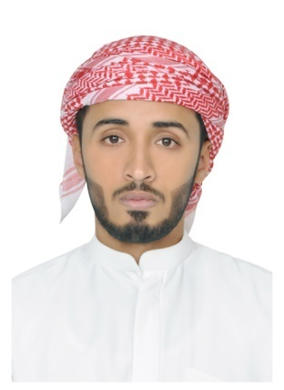
Abdallah.360209@2freemail.com
Abdallah
Personal statement

Resident with Employment visa valid until 11th January, 2019 (Transferrable)

GraduatingIslamic Finance and Banking with honours degree at| Universiti Utara Malaysia(UUM) 2017.

Personally committed to achieve and contribute to Islamic finance industry with a broad academic background and wide array of employable soft skills.

Seeking an entry level position to gain first hand experience.

Education

ISLAMIC BUSINESS SCHOOL, COLLEGE OF BUSINESS, UNIVERSITI UTARA MALAYSIA
SINTOK, KEDAH 06010, MALAYSIA
Bachelor degree (Honours) Islamic Finance and Banking
(2013-2017)

ZAYED AL AWWAL SECONDARY SCHOOL FOR BOYS, AL AIN, UNITED ARAB EMIRATES
EMIRATES GENERAL SECONDARY CERTIFICATE (Tawjihhy)
(2009 – 2011)

LANGUAGES:
- Arabic Language: Native speaker
- English Language: Professional user

Working Experience

INTERN:
(August 2016 – December 2016)
Alfalahconsulting Malaysia
Suite 14-02, Level 14 GTower
199 JalanTunRaza+k, 50400 Kuala Lumpur, Malaysia

Additional Qualifications, Awards, Workshops& Seminars attended

- UBSpayrolcertificant, Practical accreditation by Sage
- Faculty awardee for academic excellence (Dean’s List for 2015-2016).
- Executive workshops in Islamic Finance, Delegates of alfalahconsulting. KL, Malaysia
- InVaLT Leadership camp on EFFECTIVE PROJECT MANAGEMENT KL Malaysia
- Protocol manager for “Malaysian GST programme”. May 2015
- TEDxUnimap speakeron prosperity.
- UUM Youth Forum Delegate speaker on Tolerance
- SIDC workshops on Islamic capital Market: Financial Philosophy & Jurisprudence, Islamic equity products and others. March 2014
- SIDC workshops on Islamic capital Market: Financial sukuk, Islamic capital markets products and others. March 2014
- Recipient for Nemours school academic awards. Al Ain, UAE
- Jabir Bin Rashid Al Hamli 2nd Award for prophetic hadith, 2009. Abu Dhabi, UAE
- The celebrated winner for Al Ain Education Zone award for prophetic Hadith. Al Ain, UAE

My bachelor degree is set to be conferred on Nov 2017 UUM 30th annual Convocation
All events listed below have references which are available upon request

