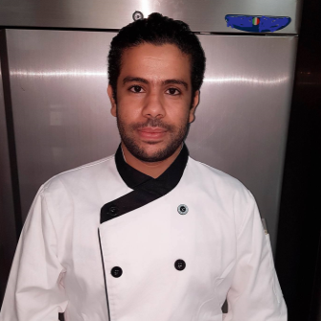 Name: Abdeljalil
PERSONAL INFORMATION:
Date of Birth: 02/04/1986
Country: Morocco
Gender: Male
Marital Status: Single
Religion: Islam
Visa status Employment
KEY SKILLS:
Languages Known: English - Arabic and French
Open minded
Able to work under pressure
SPECIALTIES:
- Implementing high quality
- Hygiene and sanitation
- Working and serving kitchen coordinating with all workstations to ensure timely delivery of freshly done orders.
- Sanitation maintenance
- Recipe development
- Quality assurance
- Financial planning
- Cost control
- Inventory check
- Beverage selection
- HACCP

Abdeljalil.360217@2freemail.com La cuisine 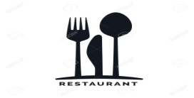

PERSONAL PROFILE:
VERSATILE, CREATIVE CHEF WITH 10+ YEARS EXPERIENCE WITH VARIOUS CULINARY SETTINGS.
HIGHLY SKILLED IN SUPERVISING THE CULINARY LINE IN A BUSY RESTAURANT ENSURING THE MAINTENANCE OF HYGIENE AND QUALITY STANDARDS.
EAGER TO EXPLORE AND IMPRINT NEW FLAVORS.

EDUCATIONAL QUALICICATION:
  - HIGH SCHOOL 2005
- 1 YEAR COOKING DIPLOMA OF SCHOOL (ISHR MARRAKECH) 2006 - 2007
- ATTESTATION OF FULL CONTACT / BLUE BELT 2008
- CERTIFICATE OF PERSON IN CHARGE(PIC) LEVEL 3 SYLLABUS,
APPROVED BY FOOD CONTROL DEPARTMENT DUBAI MUNICIPALITY 2017
EXPERIENCE:
- 2 year ++, June 2014 –Till date ( head chef ) shift- Restaurant in Damac properties, Arabic & international cuisine – DUBAI, UAE
- 1 year, July 2013 until May 2014 (sous chef ) Restaurant Royal dream Arabic FOOD – AJMAN, UAE
- 1 year, September 2012 until May 2013 (sous chef) Restaurant Emime Moroccan cuisine & international cuisine - Marrakech Morocco.
- 1 year, October 2011– until August 2012 (CDP) Villa ImaadRohamouni international cuisine - Marrakech Morocco
- 3 year 2008 until 2011(commi 1, then CDP) Restaurant Canto bar, international cuisine – Marrakech Morocco.
- 1 year, October 2007 until 2008 (commi 2) Hotel 5* Mansour eddahbi international cuisine until Marrakech Morocco.
- June until September 2006 (commi 3) in Hotel 5 * luxe Amanjena International Cuisine. Marrakech Morocco.
DECLARATION:
- I hereby declare that the above statements are true and correct to the best of my knowledge and belie.

