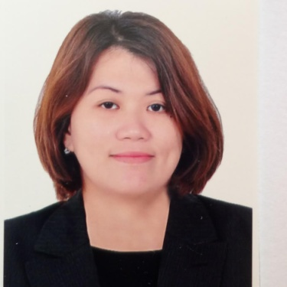

MELODY
MELODY.360221@2freemail.com

OBJECTIVES :

Seek challenging position as office assistant at a reputed company, experienced administrative work with a strong interpersonal and organizational skills. Be able to work in a multi-tasking challenges and responsibilities highly trustworthy ethical and discreet detailed, oriented and resourceful in completing task and projects.

CAPABILITIES:

- Word processing and typing
- Filing and keep document and archives
- Telephone reception
- Orchestrating multiple activities simultaneously to get things done
- Able to work well under minimal supervision
- Proficient with computer and software program such as office suite.
- Ability to multitask prioritize and think ahead.
- Accepting feedback in a professional and constructive manner.
- Willing to take challenging assignment.
- Well trained professional with experience in sales.
- Determined and motivated person
- Easily going to work with and very good in finding a solution in a problem.
- Enthusiastic and positive person.
- Trustworthy, flexible and adaptable
- Good at establishing long-term relationships with the clients.

Summary of Professional Experience:

NOVO Nordisk Pharmaceutical Incorporation (PHILIPPINES)

Taguig City,Philippines
SALES & MARKETING ASSISTANT cum RECEPTIONIST(Sample Process)
August 1,2012 - January 20,2017

NOVO Nordisk Pharmaceutical Incorporation (PHILIPPINES)
Taguig City,Philippines
Documents Control Assistant
November 19, 2012 - August 1, 2012

SODEXO Incorporation Philippines
Pasig City,Philippines
TELEMARKETER / TELESALES
March 20, 2009 - October 18,2012

CITIFINANCIAL Incorporation
Philippines
Main Office , Makati City, Philippines
CVU , Loan Processing
DATA ENTRY
May 2005 - November 2005

CITIFINANCIAL Incorporation Philippines
LoanProcessing, Cubao Branch Quezon City,Philippines
ADMINISTRATIVE ASSISTANT CUM RECEPTIONIST
January 12,2006 - January 12,2009

CITIBANK NAA Quezon City Philippines
Credit Acquisition Dept.
ADMINISTRATIVE ASST
June 2003- November 2003

EDUCATIONAL BACKGROUND:

College: FAR EASTERN UNIVERSITY
Manila, Philippines

Degree: Bachelor Sience in 1mmerce
Major in Banki19and Finance
Graduated, SY 1998

PERSONAL INFORMATION:

Sex: Female
Citizenship: Filipino
Civil Status: Single
Language/Dialect: English / Tagalog
Tourist Visa Expiry date: April 28, 2017

