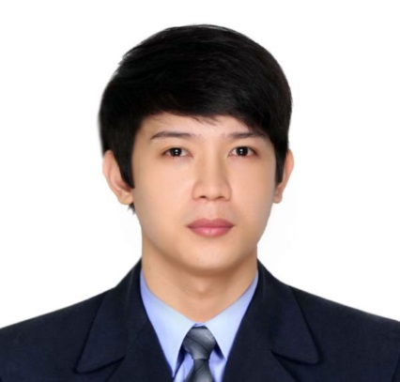
Fel
Fel.360251@2freemail.com

WORK EXPERIENCE
I have been working for 5 years

- 1.Position: IT ADMINISTRATOR
Duration: April2016 –February 2017
Company: Challenger Rent a Car & Limousine
Industry: Automotive /Vehicle
Location: Doha Qatar
Department: INFORMATION TECHNOLOGY
Job Description:
- Perform regular security monitoring to identify any possible intrusions.
- Computer Hardware/Software Installation
- Configuration and troubleshooting of IT peripherals.
- Create, change, and delete user accounts per request
- Perform daily system monitoring, verifying the integrity and availability of all hardware, server resources, systems and key processes, reviewing system and application logs, and verifying completion of scheduled jobs such as backups.
- Printer installation and troubleshooting
- Design and maintain needed hardware and software for the computer network in the company.
- Troubleshoot and fix network errors and provides technical support to end-users
- High level technical analysts with a specialty in Local Area Networks (LANs) or Wide Area Networks (WANs)

- 2. Position: INFORMATION TECHNOLOGY ASSISTANT
Duration: April 2012 – June 2015
Company: Benison Group of Companies /Abenson Inc.
Industry: Retail / Merchandise
Location: Metro Manila, Philippines
Department: INFORMATION TECHNOLOGY
Job Description:
- Assessment of POS Computer, Conduct Inventory of all IT equipment (HW&SW)
- Computer Hardware/Software Installation, configuration and troubleshooting of IT equipment.
- Perform Printer Installation and Troubleshooting
- Design and maintain needed hardware and software for the computer network in the company.
- Evaluates system potential by testing compatibility of new programs with existing programs.
- Prepares reference for users by writing operating instructions.

Technical Support Specialist Skills and Qualifications:
Problem Solving, Presenting Technical Information, Process Improvement, Software Maintenance, Software Testing, Network Design and Implementation, Load Balancing and Scalability, Vendor Relationships, Software Performance Tuning, Network Performance Tuning, Database Performance Tuning.

PERSONAL DATA
AGE: 28
Date of Birth: November 23, 1988
Gender: Male
Civil Status: Single
Height: 172.72
Nationality: Filipino
Religion: Christianity – Roman Catholic

EDUCATION
Highest Education

Education Level: Bachelor’s / College Degree
Education Field: Computer Science / Information Technology
Course: Bachelor of Science in Information Technology
Date: June 2007 – Oct 2011

TRAININGS/SEMINARS
Date Topic/Course Title

April 23-25, 2014 Samsung Smart Hotel Solutions Training and Seminar
(Samsung Company)
Address: Hanjin Building, University Parkway, North Bonifacio,Global City, 1128 38th St, Taguig

Sept 16, 2009 - Right Rail Transit Authority Depot Tour Seminar
Santolan Station Compound (LRT-A)
University Parkway, North Bonifacio, Global City, 1128
38thSt.Taguig

- National Computer Center (NCC) Tour Seminar
C.P. Garcia Ave, Quezon City

Oct 29, 2008 PC Assembly, Hardware and Software
Troubleshooting/Repair and Data Recovery with OJT
(Slow Track)

