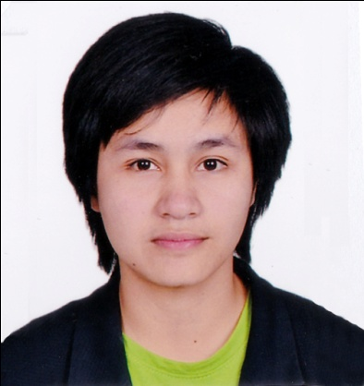
REALYN
REALYN.360253@2freemail.com

OBJECTIVES/GOAL

I want to enhance my knowledge in the field with hard work and I seek challenging opportunities where I can fully use my skills for the success of the company.

EDUCATION

Tertiary: Bachelor of Industrial Technology
Major in Electrical (4years)
Bulacan State University
(City of Malolos, Bulacan, Philippines)
School Year 2011-2015

TRAINING

- Technical drafting NCII April 8, 2016
(TESDA) Guiguinto, Malolos, Bulacan
(Draft Electrical –electronic layout, mechanical layout, Architectural
layout, Structural layout and Plumbing-Sanitary layout and details)

- Electrical and Installation Maintenance NCII March 28, 2014
(TESDA)Guiguinto, Malolos, Bulacan

WORKING EXPERIENCE

- SHILLON Global Construction, Inc.
(Electrical Installation)
Makati City, Philippines
Position: Electrician (January 2016 to October 2016)

Duties and Responsibilities
- Read blueprints or technical diagrams
- Install and maintain wiring, control, and lighting systems
- Follow state and local building regulations based on the National Electric Code
- Inspect electrical components, such as transformers and circuit breakers
- Identify electrical problems with a variety of testing devices

- ARR Industrial Incorporated
(Engineering, Constructing, Supplies, Installation, and Service – ELECTRICAL)
Quezon City, Philippines
Position: Electrician (May 2015 to December 2015)

Duties and Responsibilities
- Assemble, install, test, and maintain electrical or electronic wiring, equipment, and fixtures, using hand tools and power tools.
- Plan layout and installation of electrical wiring, equipment and fixtures, based on job specifications and local codes.
- Install electrical components like outlet, switches and break
- Test electrical systems and continuity of circuits in electrical wiring, equipment, and fixtures, using testing devices such as ohmmeters, voltmeters, and oscilloscopes, to ensure compatibility and safety of system.

• HGST Western Digital Company
(Engineering, Constructing, Supplies, Installation, and Service – ELECTRICAL)
Laguna Technopark, Binan, Laguna, Philippines)
Position: OJT - Electrician (January 2015 to March 2015)

- ARR Industrial Incorporated
(Engineering, Constructing, Supplies, Installation, and Service – ELECTRICAL)
(Quezon City, Philippines)
Position: OJT - Electrician (November 2012 to January 2013)

SKILLS

- Computer literate
- Has background in welding works
- Able to work with any type of co-worker and environment
- AutoCAD
- Adapts easily to any given or new task
- Strong wants to learn new skills
- Strong knowledge in difficulties
- Honest and Hardworking
- Knowledgeable in any electrical troubleshooting, like
- Building wirings
- Basic pneumatics
- Programmable logic control
- Electro-pneumatics

Extra-Curricular Activity
Electrical, Industrial Automation Refrigerator and Air Conditioning, Skills Competition during the Celebration of BulSU Foundation Anniversary.

PERSONAL INFORMATION

Date of Birth | : March 29, 1994 | Gender | : Female
Age | : 22 years old | Language | : English & Tagalog
Nationality | : Filipino | Civil Status | : Single
Weight | : 55 kg
Height | : 5’0” | Visa Status | : Visit Visa valid till 13 Jun 2017

