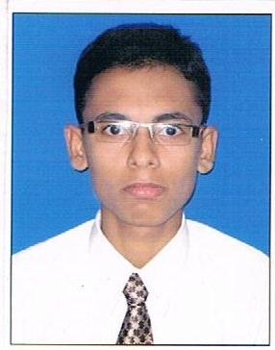 |  | Name |  | Curriculum vitae  Rajan
 |  | Rajan.360311@2freemail.com
 |  | Nationality |  | Indian
 |  | Date of Birth |  | 11/01/1993
 |  | Gender |  | Male

My Skills Summary
Safety-minded and a good communicator with strong computer skills. Excellent listening skills, oral and written communications excellent problem solving and negotiating skills.
Career Objective
“To work in association with professional groups who offer me the opportunity for career advancement and professional growth.”
Working Experience

- Worked with “Parsad Enterprises” As a Sr. Executive Supervisor in the “BFSI” operations and Transaction team, from 15rd Nov 2013 to 23rd Dec 2016.
- Worked as a Commercial Executive, handle all kind of transaction Cash, card, voucher and all kinds of offer gift coupons Store department in Back office team of Dhanbad.
- Sending daily Staff attendance to HO,
- As per daily basis create transaction report against of purchase order and good receive note.
- Day to day banking activities related to cash card and voucher and report to HO .
- Procuring Business from existing customers and customer’s service
- Main ting store stock and inward and outward the goods as per need
Handled sell, purchases account, debit and credit account.
- Received payment from Customer, generate bill as per work and material.
- Generate Sales Order; capture all staff day to day activities.
- Generate weekly or monthly data report in excel.
- Generate Daily closing dashboard and opening checklist.
- Updating at the system customer loyalty point and share holder detail.
- As per daily basis report to Ho staff attendance.
- Updating weekly off staff roster.

Training Detail-- Attended 17 days Training Programmed on, Retail sales and service excellence. In contain communication Skill, & personality development under NRLM initiated by MORD in association with NABCONS & provided by future learning at Vill-Uttrain,P.s-Konch,Dist-Gaya (Bihar) 824207
Proficiency Skills
Desire and ability to learn new things in a short duration.
Logical reasoning and analytical skill.
Academic Qualification
Passed Bachelor in Business Administration from Sikkim Manipal University in 2013
Passed HSC from SSY College(B.S.E.B) with 1st Class Distinction in 2010.
Passed SSC from Gandhi high School(B.S.E.B) with IInd Div.in 2008.
Professional Qualification
Passed certificate in Advance Diploma Computer Application from Pahal Kaushal vridhi yojna 2008.
Personal Details

Date of Birth 11 .Jan.1993
Sex Male
Nationality Indian
Marital Status Single
Religion Hinduism
Language Know Hindi & English
Declaration
I do here by declare that all the information above mention is true & correct from the best my knowledge.

