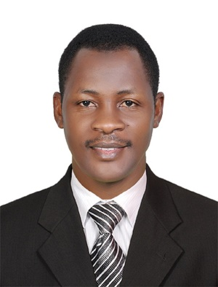
Kassim

Kassim.360379@2freemail.com

Applied Post: SECURITY GUARD/CCTV/ LOSS PREVENTION.

Career Objective:
A suitable position within an organization where I can utilize the best of my skills and abilities based on my education, skills and experience and place where I am encouraged and committed to be an active participant as well as a vital contributor in the development of the company
PROFESSIONAL EXPERIENCE:
6 years Experience in Dubai
Most Recent Employer:
Bukhowa Investments LLC
Office#1507 Concord Tower Dubai Media City
Most Recent Professional Position:
Loss Prevention Advisor.
Period : Nov. 2015 - 21st March 2017
Company : Bukhowa Investment LLC
Client : Bukhowa Investments LLC, Office 1507, Concord Tower,
Dubai Media City.
Position : Loss Prevention Advisor
Responsibilities : Installation of Cameras
- Tallying of footage and sales reports for accurate reports.
- Reporting incidents to operations manager.
- Holding meetings with area managers.
- Holding Disciplinary meetings with staff.
- Regular checking of storage capacity and restarting DVRs in case of power shutdown
- Configuring & integration of cameras into POS system.
- Adjustment of camera to proper positions.
- Controlling theft of cash by any staff
- Checking on all activities of staff in stores and
Naming of cameras as par their Locations
Period : Dec. 2011 – Nov. 2015
Company : Securiguard Middle East
Client : Cayan Business Centre Tecom-Al Barsha and Adagio Hotel
Premium Apartment.
Position : Security Guard/ CCTV Operator
Responsibilities :
- Monitoring CCTV Camera
- Patrolling
- Controlling Access
- Writing & Reporting Incidents.
- Record Keeping
- Answering Phone Calls at Reception
- Reporting incidents.
- Reading the fire panel control system, resetting & Muting alarm faults.
- Protecting information
- Access Control
- Handling & Keeping of lost & found items.
- Handing over lost & found items to their owners attending to calls from front office & from guests.
EDUCATION INFORMATION:

Year | School/Institution | Award
2004-2007 | Kyambogo University Kampala Uganda | Diploma in Education Primary
1999-2001 | Buhungiro Primary Teacher’s College | Grade III Certificate
1997-1998 | Ibanda Secondary School | Uganda Advanced Certificate of Education
1993-1996 | Nombe Secondary School | Uganda Certificate of Education
1986-1992 | Rwamukondo Primary School | Primary Leaving Examination

Other Awards:

July 2001 | Security Group Uganda Ltd | Certificate
December 2007 | Federation of Uganda Football Association | Referee Grade III Certificate
February 2011 | Ministry of Education & Sports | Primary Six New Curriculum Awareness Certificate
February 2012 | Department of Protective Systems | DPS Certificate
Computer Skills:
Period : Micro Soft word 2000, Excel, Word Processing,
Internet, E-mail, Spreadsheets, graphics.
PROFESSION SKILLS:
- Good English communication skills,
- Good Customer care & Hospitality
- Fire prevention & fire fighting skills.
- Health & Safety Skills.
- Ethics & Professionalism skills.
- CCTV operation & Monitoring skills.
- First Aid

