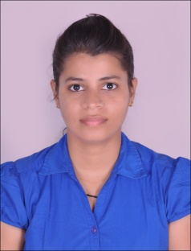
RESUME
Ms.Kritika
Kritika.360386@2freemail.com
Experience:
- 1: Currently working at The Geekay World School, Vellore, Tamil Nadu as a Pre-Primary Incharge (17th April’2016 onwards).
- 2: Previously worked at The Tree House Education & Accessories Ltd, Kolkata, West Bengal as a Pre-Primary Teacher (26th August’2014 to 26th September’2015).
Objective:
To secure a position in teaching & share my knowledge for the growth and development of the children.
Educational Background
- PursuingB.Ed (final year) from Singhania University, Rajasthan.
- Completed B.Com (Hons.) from Calcutta University in 2015.
- Passed Higher Secondary from W.B.H.S.C.E. in 2010.
- Passed High School from I.C.S.I. in 2008.
Professional Qualification:
- Pursuing International Certificate inEducation in Preschool Professionals from Asian International College, Singapore.
- Certified in Common European Framework of Reference for languages (CEFR) at B1 Level.
- Completed T.T.C. from Calcutta Montessori Training Centre, Kolkata in 2015.
- Passed computer professional in MS-Word, MS-Excel, MS-Power Point,and TALLY ERP9.
Skills:
- Able to incorporate fun games and interactive activities into lessons.
- Intensive knowledge on how to establish good relationships with children.
- Certified early childhood educator.

Interests:
- Interaction with children.
- Teaching.
- Dancing.
- Travelling.
- Cooking.
Strengths:

- Excellent Verbal and Communication skills.
- Honest.
- Kind.
- Loving and Caring.
- Strict when required.

Personal Information:

.
Date of Birth: 20th February’1992.
Nationality: Indian
Languages Known: English, Hindi and Bengali.

Declaration: I do here by declare all the above stated information’s are true to the best of my knowledge and belief.

