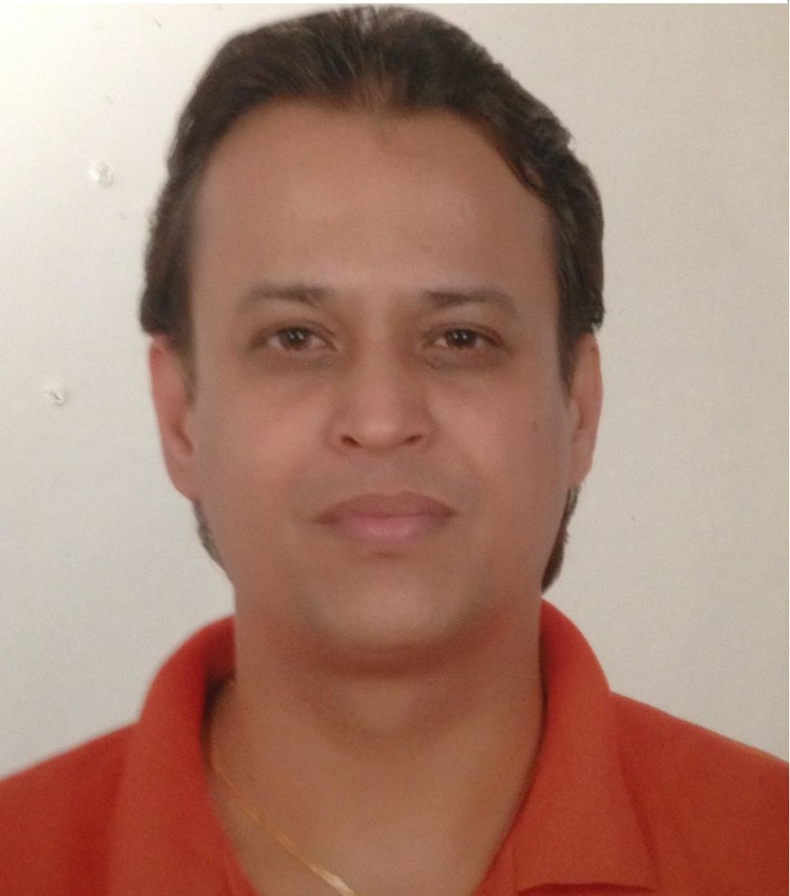
Pranav
Sharjah, U.A.E.
Pranav.360394@2freemail.com

Date of Birth: 2nd November, 1975.
Occupied U.A.E. Driving License No. 3.

15+ years of experience of various field of Sales Field.
Accountant, Sales, Marketing, Customer Care, MIS Coordinator with Overall 23+ years of experience.

PROFESSIONAL EXPERIENCE

AL SHAALI MOTO TRADING EST. Dubai, UAE
May 2011 – Present
KEY ROLE & RESPONSEBILITIES.
Sales Re-presentative.
- Approach and assist new customers that enter the dealership lot.
- Determine the needs of the customer by listening and asking questions.
- Perform walk-around with customer and demonstrate features of suitable automobiles.
- Effectively close automotive sales.
- Ensure the customer understands the vehicle’s operating features, warranty and paperwork.
- Maintain an owner follow-up system that encourages repeat business and referrals.
- Reports to the sales manager regarding objectives, reviews, analyses, and planned activities.
- Attends training and sales meetings offered by the dealership and manufacturers.
- Review sales statistics and actions to determine how to better utilize time, plan more effectively, and improve sales.

MODERN BUILDING MATERIAL TRADING L.L.C. Dubai, U.A.E.
Jan 2010 – April 2011
KEY ROLE & RESPONSEBILITIES.
Sales Executive
- Identifies business opportunities by identifying prospects and evaluating their position in the industry.
- Researching and analyzing sales options.
- Sells products by establishing contact and developing relationships with prospects.
- Recommending solutions.
- Trained and supervised new employees, ensuring they maintain fastidious attention to detail.

ABE HAYAT GENERAL CONTRACTING L.L.C. Dubai, U.A.E.
Jun 2006 – Dec 2009
KEY ROLE & RESPONSEBILITIES.
Sales Executive.
- Maximize income generation for the company, and achieving sales targets.
- Coordinate all aspects of the sales process from initial enquiry/RFP through to closing of the opportunity.
- Generate project/business opportunities to meet company’s business plans and growth strategies.
- Drive the development and implementation of the sales and marketing strategy.
- Undertake research to identify opportunities and threats in the market place.
- Attend networking events, trade exhibitions and promotional events to gather market information and promote the system/product.
- Monitor customer satisfaction, implementing procedures and activities to compile client feedback.
- Ensure that all marketing materials, documents and correspondence are updated and adhered to the corporate image.
- Represent the company in a professional manner at all times.
- Develop solid, long-term relationships with prospects and maintain existing customer’s relationship within the commercial construction industry.
- Follow up with the client along the execution of the project.
- Track and report current status of potential projects, markets, Customer news, and developments.
- Lead the development and preparation of RFP’s, Pre-Qualification, formal presentations, proposal, and contracts.
- Ensure all communication with customers is in accordance with our standards and correct in content and format.
- Implement Company Policies and Procedures.
- Perform other duties as assigned.

BHARATI CELLULAR LIMITED. Ahmedabad, India
Jan 2005 – May 2006
KEY ROLE & RESPONSEBILITIES.
Sales Executive.
- Territory/Cluster wise maping.
- Seprate maping data with allocated groups.
- Field visit retail, SME & Corporate outlet to educate for products.
- Manage & Distribute collected information to the Sales Department.
- Verification and validation of Customer Application Form.
- Verification and validation of Customer documents.
- Compilation of various MIS related for Sales/ Business activities.
- On-line of Sales/ Business Portal Entry.
- Preparation of Daily Business Report & Daily Dash Board.
- Resolving Sales Order Pendency and Compilation of MIS regarding SO.
- Compilation of various Technical Report based on RFS/ Non RFS Area.
- Maintain relationship with Enroll and Nonenroll Customers.
- Give best after Sales Service.

RAJU SERVICES. Ahmedabad, India
April 2000 – Dec 2004
KEY ROLE & RESPONSEBILITIES.
Sales Executive.
- Regular visit to the Person as per a journey cycle.
- To keep in constant touch with the market.
- To educate Person of the TATA TELESERVICES.
- To act as de-facto with between firm and person.
- To keep track of the sales.
- To solve Person problem.
- To get competitor information.
- Identification of potential person, not selling teleservices products to increase channel based & thereby breadth of teleservices.
- Solve routine teleservices related issues faced by person as per teleservices guideline.
- Effective roll out of teleservices designed program and promotions followed by monitoring & analysis of the activity promotion.
- Work towards achieving pre-defined targets in term of business volume & number of persons.
- Ensure attendance at teleservices held events.
- Spot Marketing opportunities and keep teleservices updated regularly on the market.
- Suggest Marketing program & roll out after teleservices approval.
- Reward:Sign of Excellence (Tata Teleservices Ltd…Award)

BUSYWIRES INFOSYS PVT. LTD. Ahmedabad, India
Mar 1995 – Mar 2000
KEY ROLE & RESPONSEBILITIES.
Sales Executive.
- Regular visit to the Person as per a journey cycle.
- To keep in constant touch with the market.
- To educate Person of the Busywires Infosys.
- To act as de-facto with between firm and person.
- To keep track of the sales.
- To solve Person problem.
- To get competitor information.
- Identification of potential person, not selling Infosys products to increase channel based & thereby breadth of Infosys.
- Solve routine Infosys related issues faced by person as per Infosys guideline.
- Effective roll out of Infosys designed program and promotions followed by monitoring & analysis of the activity promotion.
- Work towards achieving pre-defined targets in term of business volume & number of persons.
- Ensure attendance at Infosys held events.
- Spot Marketing opportunities and keep Infosys updated regularly on the market.
- Suggest Marketing program & roll out after Infosys approval.

EDUCATION

ATTEMPT BACHELOR OF COMMERCE Gujarat University, India
Specialization in Accounting, 1996

CERTIFICATEOFHIGHERSECONDARYHIGHSCHOOL. Gujarat Secondary Education Board, India
Specialization in Accounting, 1993

ADDITIONAL SKILLS

- Knowledge of Tally and all Microsoft Office Applications
- Excellent communication skills, and ability to present complex information in an easy to understand format

CERTIFICATIONS

- Certified M.C.A. (Master in Computer Application), 1997.

CURRENT SALARY

- AED 7,500

