360457@gulfjobseekers.com 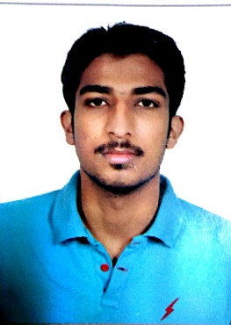

Aim and Objective:
Challenging position in your field, which will give me the best possible opportunity and job
Satisfaction to prove my ability based on my education and experience which was gained.

Personal strengths:

- Clear cogent communicator with excellent written and verbal skills
- Systematic and organized individual committed to successful results
- Can be easily trained and can work with less supervision
- Hard working and goal oriented Human Resources Coordinator with good managing skills
- Enthusiastic team player with proven interpersonal skills
- Good interpersonal skills
- Self-motivated coordinator with a “Service with a Smile” attitude

Qualification:

YEAR DEGREE INSTITUTE Grade
2012-2014 | Diploma of Mechanical Engineering | Indus institute of higher education Karachi | 85% (A)
2009-2010 | Matric(Sindh Board Of Secondary Education) | Methodist school Karachi | B

2012 (February) | MS-OFFICE COURSE | The designers academy, Computer training school

Experience:
2014-2015:
As an IT charge at The Smart School Shah Faisal Colony Karachi, Pakistan.

Technical Skills:

- Internet
- MS-Office
- Auto-CAD
- Familiar with Internet and other network applications
- Customer Service
- Windows 98 / XP/ Vista

Personal Characteristics:
Team player, readily accepts challenges

Languages:
English, Urdu, Punjabi, Hindi

Reference :
References available upon request.

