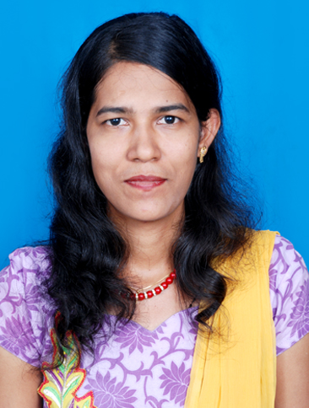
JESINTHA

JESINTHA.360619@2freemail.com

Objective
To use the skills, knowledge and experience I have gained through tertiary study and work experience to educate and provide students with the necessary learning they require to develop in today’s society. I have a strong interest in all areas of education and am passionately committed to promoting a positive and dynamic learning environment for primary and secondary school students and to the work that is entrusted with.

Education
Kuvempu university
Shivamoga (Karnataka)
Masters in Mathematics(M.Sc)
Post graduated:2014
Percentage: 55%

St. Aloysius College
Mangalore.
Bachelor of Education (B.Ed)
Graduated: November 2012
Percentage: 78 %

Maharani College, Banglore University
Bangalore.
Bachelor of Science (B.Sc)
Graduated: November 2009
Percentage: 69 %

Employment History
May 2009 – April 2010: Mathematics / Science Teacher (one year contract)
St. Mary’s School, U.P(ICSE)
Responsibilities:
- Planning and creative and innovative way of welcoming the parents.
- Marking work, giving appropriate feedback and monitoring to the needs of the students and parents.
- Liaising with parents about their child’s progress
- Preparing students for examinations
- Keeping up to date with any new developments, resources or methods available within the fields of Mathematics / Science
Achievements:
- Initiated magazine for students to display their creative writings and paintings
- Initiated outreach programs for students to teach poor children once in a week
- Initiated study groups to help weaker students
May 2010 – April 2011: Mathematics / Science Teacher (one year contract)
St. AloysiusSchoolMangalore(STATE BOARD)
Responsibilities:
- Planning and delivering lessons in accordance with Territory curriculum to a range of classes
- Marking students’ homework and classwork
- Answering student queries relating to classwork/homework
- Keeping up to date with any new developments, resources or methods available within the fields of Mathematics / Science

November 2012-May 2013: Mathematics and science teacher
Vignesh international school Chennai. Tamil Nadu(CBSE)

Responsibilities:
- Planning and preparing innovative way of making the lesson plans.
- Marking work, giving appropriate feedback and monitoring to the needs of the students and parents.
- Conducting after-school study groups for students
- Preparing students for examinations and activities.
June2013 – till date-working asvice principal and Math’s faculty
St. Aloysius English high school. Bhayander (e) Mumbai

Responsibilities:
- Planning and creative and innovative way of welcoming the parents.
- Marking work, giving appropriate feedback and monitoring to the needs of the Teachers and students.
- Conducting meetings with parents about their child’s progress in small groups.
- Planning and preparing the examination schedule.
- Preparing students for examinationsPlanning and delivering lessons in accordance with Territory curriculum to a range of classes
- Planning and preparing the schedule of the Teachers.
- Updating the registers and minutes of the meeting.
- Keeping up to date with any new developments, resources or methods available within the fields of Mathematics / Science.

PERRSONAL SKILLS
- Excellent written and oral communication skills.
- Strong problem solving skills.
- Excellent Interpersonal and Negotiating skills.
- Ability to identify and follow up new methods of teaching.

PROFESSIONAL SKILLS
1.Communication skills: possess the ability to communicate well with people in English, Hindi, Kannada and Konkani.

2. Commuter skills.
Category | Name | Proficiency | Yrs Experience | Last Used
Computer | Microsoft Office | Intermediate | 3+ yrs | use currently
Teaching | Using Electronic Whiteboard | Intermediate | 1+ yrs | use currently
OS | PC Platform | Intermediate | 3+ yrs | use currently
AREAS OF INTEEREST
- Creating innovative teaching Ideas.
- Reading books and magazines
- Updating my knowledge on the latest management practices.

PERSONAL PROFILE
Date of birth :20th June 1980
Sex : Female
Nationality : Indian
Marital status : Married

DECLARATION
I Hereby declare the in formations are given above are true to the best of my knowledge and belief.

