Ahmed
Ahmed.360696@2freemail.com

SUMMARY & OBJECTIVE
Unique dedicated hard worker, top performance achiever, premium quality provider and ambitious person, aiming to be associated with a progressive organization that provides me scope to apply my gained experience and professional skills to contribute success.

SKILLS
Functional Skills | Self-management Skills
- Fluent Trilingual (English, Arabic & French)  - Cross-Culture communication  - Team Work  - Selling & promoting skills  - Presentation Skills  - Conflict resolution | - Influencing, persuasion & negotiation skills  - Multi-tasker  - Energetic &Positive attitude “Can Do attitude”  - Tolerance for stressful situations  - Adaptability
Other Skills
- Portrait and Landscape Photography
- IT languages: HTML & CSS
- Health and Safety regulations

WORK HISTORY
11/2015  To Present | 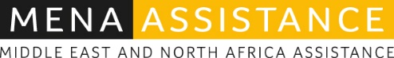  Customer Service Representative  MENAA, Dubai – UAE  Providing Road side assistance for multiple vehicle brands and luxury lands, within the region of north Africa to Arabian Gulf.
05/2014  10/2015 | 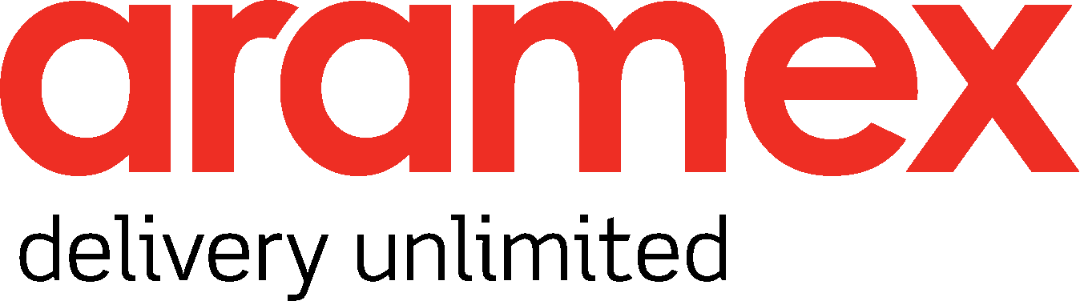  Customer Service Management  ARAMEX, Dubai – UAE  Customer service representative, providing logistic solutions and cargo services, suited in company uniform and located in branches and service points, responsible of cash transactions and payments, and following up with clients and customers.
09/2013 to 02/2014 | Customer Support &Technical Adviser  Vodafone International Services, Cairo – Egypt  Customer service representative, providing full support over the phone for Vodafone UK customers, located in VIS call center in Cairo, responsible to answer customer’s inquiries and follow up via e-mail.
03/2012 to 07/2013 | Technical Advisor  VIDEOTRON Quebec, Cairo – Egypt  Customer service representative, providing bilingual technical support over the phone for Videotron Quebec customer, located in XCEED call center in Cairo, responsible to answer customer’s inquiries and provide technical solutions, monitor and alert any regional issues.
04/2011 to 03/2012 | Listener Care Adviser  SIRIUSXM USA, Cairo – Egypt  Customer service representative, providing billing and account management services, located in Stream Global Services call center in Cairo, responsible to answer customer’s inquiries, manage their accounts and assist for any payment due.

ACCOMPLISHMENTS
SiruisXM : Top performer in quality and customer satisfaction for 3 quarters, full adherence and attendance over 100%, in charge for new batches calibration and briefing.
Videotron: Top in customer satisfaction and first call resolution, first bilingual representative (FR & EN), Best technical solutions sales, perfect adherence and quality star.
VIS : Top achiever in AHT and ACW.
Aramex : Surprisingly premium customer service and hospitality reward in 2014 last quarter.

EDUCATION& CERTIFICATES
2012 B.A Language art and interpreting (FR, EN & AR) GPA: GOOD
New Cairo Language institute, Cairo – Egypt
2013 DELF B1
French center of culture and cooperation, Cairo – Egypt
2007 ICDL
Heliopolis technology institute, Cairo – Egypt
2015 Health and Safety
Frist AID, CPR, AED & firefighting certificates from National Safety Council, Dubai – UAE

2015 Driving license
Dubai – UAE

