Muhammad

Muhammad.360735@2freemail.com 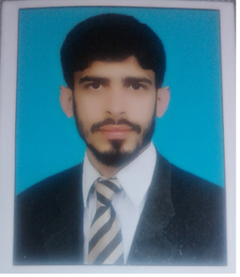

Objective:

To work in a required organization that may utilize my skills and provide me a challenging and motivating environment for my personal learning so that I can do something for the welfare of this organization as well as of this state.

Education:

DAE Civil 2009-2012 PBTE - LAHORE
Govt: College Of Technology Bahawalpur

Matriculation (Science)
Govt: High School Gogran, Lodhran 2007-2009 BISE – MULTAN

Computer Skills

- AutoCAD 2d & 3d
- Autodesk 3ds Max
- V-Ray
- Adobe Photoshop
- MS Office
- Internet browsing, Email etc.
- Operating systems (Windows XP, 7,8 and 10)

Internship Training:

- 6 Months of training in Ideal Home Associates Bahawalpur. (Aug: 2012-Jan: 2013)

Intern:
- To draw 2d plans.
- To draw Architectural and Structure drawings.
- Sections and elevations.
- Submission drawings.
- 3d visualization In 3ds max.
- Site supervision.
- Layout of building.
- Brick masonry work.
- Plaster work.
- Marble & tile fixing.
- Paint work.
- Shuttering work.
- Steel fixing.
- Concrete work.

Experience:

- 1 year in WHITE ROSE INTERPRISES PVT LTD: BAHAWALPUR. (Feb:2013-Feb:2014)

Site: QUAID E AZAM SOLAR PARK BAHAWALPUR.
Experience:

- Layout of buildings.
- Supervision of construction site as a leader.
- Meeting with the clients and consultants.
- Coordination with site staff and construction activities at site.
- Distribution of manpower regarding work.
- Ensuring and supervision of work according to specification / drawings.
- Solving day to day problems of the drawings according to contract documents.
- Daily meeting regarding progress of work and hardless.

- 3 year in Ideal Home Associates Bahawalpur.(Architects,Engineers,Contractors, Builders,Consultants And Designers) (Mar:2014-Mar:2017)

Experience:

- Planning of projects.
- Architectural and structure drawings.
- Submission drawings.
- 3d visualizing.
- Site layouts.
- Site supervision. Ensuring of work according to specifications/drawings.
- Accounts matters.
- Clients dealing.

Professional Skills

- Strong motivational and leadership abilities.
- Excellent communication skills in written & verbal both.
- Good convincing power.
- Ability to produce best result in pressure situation.
- Ability to work as individual as well as in group.
- Able to start work immediately.

Field:

- Excellent communication skills, self-motivated, self-starter and proactive,
- Leadership skills and ability to lead a small project team and work individually as well.

Communication Skills:

- English
- Urdu
- Punjabi

Hobbies:

- I have interest in reading different types of books.
- I have interest in searching of intersting scientific knowledge.
- If am fond to meet technical persons.
- I have interest in sports like Cricket , Tennis & Basket ball

Reference

Reference will be furnished upon request.

