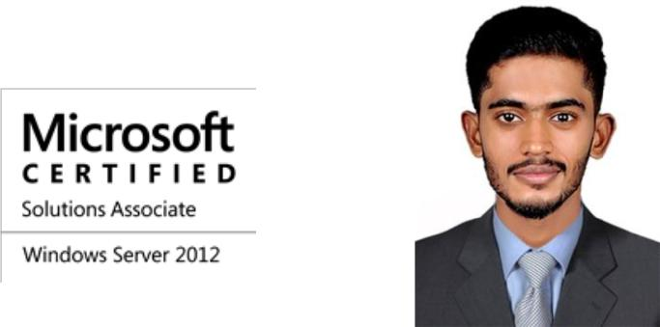
MOHAMMED
MOHAMMED.360738@2freemail.com

Career Objective.

To obtain a challenging position in a progressive and technologically driven company, where I can utilise and expand my IT knowledge for the prosperous growth of the company. As a professional I am creative, innovative and looking ahead to work in challenging environment and strive for excellence.

Qualifications.

- Program in Linux (Redhat) Administration from Accel IT Academy, Thrissur, Kerala, India. (6 months passed out in 2016)

- Secondary School(NIOS) from Newman’s college Kunnamkulam, Kerala, India (6 months passed out in2016)

- Diploma Computer Hardware& Network Engineering from Accel IT Academy Thrissur, Kerala, India. (1 Year passed out in 2015)

- Diploma in Computer Engineering from Technical Board, Kerala, India. (3 Years passed out in 2013)

- Technical High School Leaving Certificate from Technical Board, Kerala, India(3 Years passed out in2010)

Experience.

- Service Engineer in Fortune Computers, Kerala, India from June 2014 to December 2016.

- Technical Support Engineer in Alfa Associates, Kerala, India from April 2013 to April 2014.

Certifications.

- Microsoft Certified Professional (MCP) – Windows Server 2012.

- Microsoft Certified Solutions Associate (MCSA) – Windows Server 2012.

Skillset Summary.

- Windows Server Administration.

- Network Administration.

- Backup Administration.

- Linux Administration.

- Windows Desktop Administration.

- Helpdesk and Technical Support

- Hardware and Troubleshooting.

- Routing and Switching.

Academic Projects.

- Backup Solution for Active Directory and Systems: -Custom developed backup solution for the entire network and systems including system state, active directory, file systems, event logs etc.

- Biometric Time and Attendance System: - Web application based on finger print reader for maintaining employee attendance and producing various reports.

Training.

- One month training on Computer Hardware Maintenance and Basic Networking in

Rambus the Network Academy, Thrissur, Kerala, India.

- One Day training on Computer Hardware and Networking from Zion Computer Hardware and Networking Institute, Kochi, Kerala, India.

