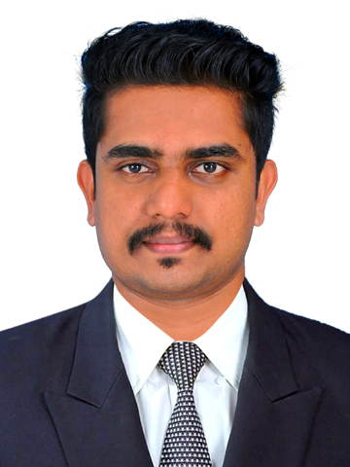  MUHAMMAD  MUHAMMAD.360749@2freemail.com  About Me  Date of birth:  September 11, 1991  Languages:  English, Malayalam, Hindi, Tamil, Arabic.  Nationality:  Indian.  Visa Expiry Date:  22/06/2017  Marital Status:  Single  Visa type:  Visit visa  ACADEMIC AND PROFESSIONAL QUALIFICATION  1.MBA-specilized in Financial management  (Bharathiar university 2014-2016)  2. M.com-specialized in Accounting and taxation  (Pondicherry university 2012-2014)  3.B.com- Specialized in computer application  (Calicut university 2009-2012) | CAREER OBJECTIVE  To acquire a demanding Accounts position in an organization where I can utilize my skills and work with efficiency, effectiveness and team effort to contribute to the success of the organization by making valuable inputs through constant learning.  PROFESSIONAL SUMMARY  - Qualified master of commerce from Pondicherry university in India and  - Qualified master of business administration from bharathiar university  - Work experience in accounts from Thai group of companies .  - Work experience in management from SML finance  - Have excellent skill in accounting and can handle up to finalization.  - Well versed in Computerized accounting environment like MS Office with advanced spread sheet skills and Tally and Peachtree.  PROFESSIONAL EXPERIENCE  Employer :Thai Group Of Companies  Designation : Branch Head  Period of Employment: June 2014- June 2016  Roles and responsibilities:  - Administer the preparation, distribution and reporting for payroll as per the guidelines prescribed by department of finance.  - Updating accounts right from journal entry to finalization of accounts and preparation of financial statement  - Initiate salary remittance to banks as well as the issuance of pay checks to company employees on monthly basis.  - Maintain all payroll general ledger accounts and personnel budgetary balance for all company accounts in Tally.  - Calculate wages, overtime, and deductions to ensure compliance with the company guidelines/procedures.  - Prepared bank reconciliation statements and value added tax statements  - Practicing accounting activities up to finalization of accounts  Employer :SML Finance Private Limited  Designation : Assistant Branch Manager  Period of Employment: June 2016- feb 2017  - Preparation of various accounting reports like ageing analysis of receivables and payable, income and expenditure statement  - Preparation and filing of Vat Returns, Service Tax returns,TDS  - Prepared daily and monthly reports (MIS) and send to head of the departments  - Handling/Responding to client across various geographies  TECHNICAL SKILLS  - Operating system: Windows,MS DOS  - Languages : MS office (Word, Excel, Power point...)  - ERP : TALLY,PEACHTREE  PERSONAL STRENGTHS  - Strong Interpersonal and Analytical Skills  - Ability to Take Initiatives and ‘Can Do’ attitude.  - Adapt to Changes easily and Learn new things to give Value Add.  - Ability to work with team and individually with minimum supervision  DECLARATION  I hereby certify that the details furnished above are true and accurate to the best of my knowledge

