Adisa
Adisa.360751@2freemail.com
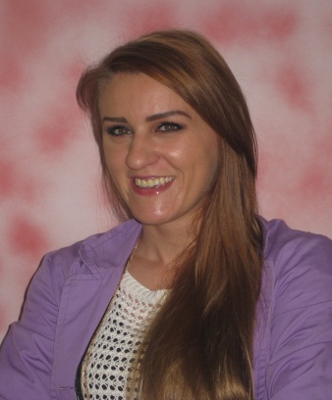

EDUCATION
•UNIVERSITY IN TUZLA – Faculty of Philosophiy , departmental of Pegogy - Psychology
Occupation: Graduate Pedagogue - Psychologist, four-years study, the study was finished on 13.10.2010.
•HIGH SCHOOL: Gymnasium , graduated in 2006/2007 school year
- First year on master's degree in University in Sarajevo, departmental of Pedagogy

WORK EXPERIENCE

- One year and 6 months in „ International high school „ Sarajevo as a psychology teacher and , one year and 6 months in „ International prymary school “ as a school pedagogue – psychologists.
I was teaching psychology on english language and also worked with many children, psychological work on english language. Children are comming from different countries of the World.
- One year working as a pedagogue – psychologist in primary school “ Zaim Kolar ” , Dejčići, Trnovo - Sarajevo. I had worked there since August 2013 to August 2014, one school year, as a probationer and substiitute of pedagog who had worked as the director of the school.
- Volunteer work with pedagogue - psychologist in elementary school "Kladanj" in Kladanj, for a month, in 2011.
- One month of volunteer work in a kindergarten in Kladanj in 2010.

SEMINARS AND PROJECTS:
• Attended seminars and expert tims which are been organized by Education – Pedagogical Institute of Sarajevo ,on july 2013 and in january 2014. The main topic of seminars was „Active learning “.
• Participated in “Project support and development of inclusive practice in Canton of Sarajevo”, organized by “UNICEF” and “DUGA” in january 2014. Topic of project was „Forming a schools tims for inclusive“ .
- Content and Language Integrated Learning CLIL – symposium

PROFESSIONAL EXAM - PASSED: 2.6.2014.

LANGUAGES
• Bosnian: Mother language.
• English language - good understanding, speaking and writing, lay knowledge test in high school, attended a course of English language at Step in Tuzla and course of English in an educational institution, "King Fahd".
- Intermediate level – New headway
- Aptic certificat of englis language ( British council) – listening and reading C , writing B1
WORK ON COMPUTER: Microsoft Word, Exel, PowerPoint,and Internet.

PERSONAL CHARACTERISTICS
• Reliable in assigned tasks
• Empathic relationships
•Very good relationship with children and adults

SOCIAL SKILLS
• Good at motivating other people or children
• Good team working

