Younes
Younes.360798@2freemail.com

PROFILE

As recent graduate from Hassiba Ben Boali University, with degrees in hydraulic engineering, I

have undertaken several internships with leading organizations such as “ADE” L’Algérienne des eaux.These placements have enabled me to develop not only specific engineering experiences,

but also a valuable and transferable skills set in this fast-paced sector in addition to skills gained from my work as a pharmacy assistant for more than 6 years .

During placement with ADE, I worked in the engineering section and managed,supervised and resolved water supply system problems,listening to clients and people complaints and guarantee

the best service. Utilizing excellent communication skills, I developed and maintained successful working relationships with both internal and external staﬀ.
My passion for Learning and for healthcare gave me the ability to develop and grow some inte-

resting potentials. i also gained experience in maintaining administrative records such as pharma-cy files,patient profiles,and in providing excellent customer care by accurately dispensing pres-
cribed medications.

EDUCATION

March 2014 June2013

January 2011 March 2010 June 2008

Junior hydraulic engineer : Speciality Urban Hydraulic.

Licentiate's degree : Speciality Urban Hydraulic.

IT Diplomat (Microsoft : Word, Excel, PowerPoint).

Diploma of Pharmacy Assistant.

Baccalaureate: Experimental Science.

STUDIED MODULE:

hydraulics urban, general hydraulics, geology, hydrogeology, soil mechanics, concrete rein-forced, frame metal, the dam, wave and vibration, mathematics applied, drawing industrial, topography, resistance of materials, physics (mechanical - electricity, , organic chemical, economy, English,statistical, data-processing, electromechanical,adjustment of the races of

EXPERIENCE

May 2014

April 2013

May 2010

Worked for Almost year in “ L’algerienne Des Eaux” The 1st Supplier of drinking water in alge-ria and supervised realisation of some big projects.

Intrenship in a design department (engineering Oﬃce) for 1 month.

Pharmacy Assistant : 7 years.

LANGUAGES

ARABIC - NATIVE ENGLISH - EXCELLENT FRENCH - EXCELLENT
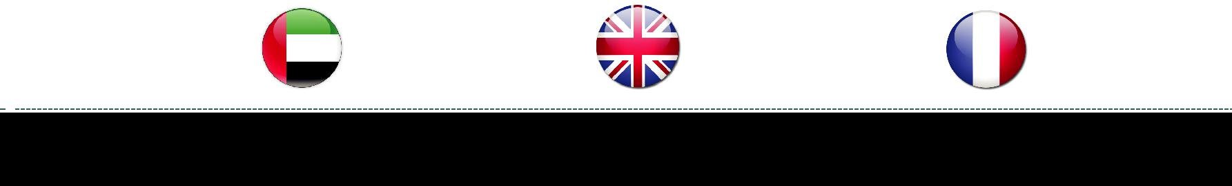

NEXT PAGE

SKILLS

Excellent managerial skills for handling a big staﬀ in the technical team and international teams too.

Instructing - Teaching others how to do something.

Strong capability to perform well even under stressful conditions.

Special attention to the details.

Strong analytical and innovative skills.

Confident with a range of IT packages including Word, Excel, Powerpoint,internet and e-mail.

Adept in using computer and researching.

Extreme attention to details in all work.

Excellent work ethic needed to succeed in any career.

Good at carrying out independent surprise inspections to evaluate that the work is going smoothly and as per the scheduled plan.

Pharmaceutical operations.

Vendor relations/negociations.

Prescriptions dispensing and compounding.

Licensing issues and regulatory compliance.

Service Orientation - Actively looking for ways to help people.

Ability to learn and master new consepts.

Client need assessement and response.

positive work ethics and commitement to providing best service.

ADDITIONAL SKILLS

Working with CAD, Inventor and 3Dvisualisations the design and technical department utilise the latest versions of computer.

Basic Knowledge in Design Softwares such as :

Adobe Photoshop | Adobe Illustrator |  | Adobe Muse | 3DsMax

