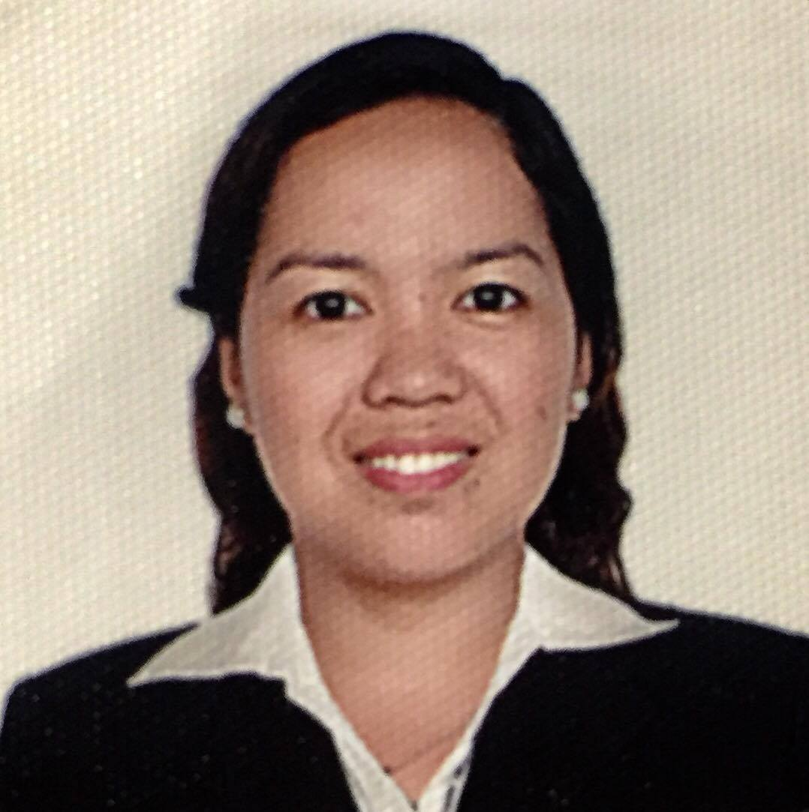
Rutchel
Rutchel.360804@2freemail.com

PROFILE SUMMARY
Business Analyst in profession with over 3 years of experience who specializes in defining, gathering and analyzing information and data to formulate requirements based on company’s processes and procedures and ultimately provide recommendation and deploy strategies designed to solve the issues. Practiced as a QA/Test Engineer for 3 years which also focuses in creation of end-to-end test plan, execution and handling of plan to ensure requirements and objectives are met and that output works as expected.

Strengths
• Demonstrated equally effective skills in planning, requirements gathering and analyzing of data
• Conduct and facilitated User Acceptance Testing (UAT)
• Fast-learner and perform effective quality assurance for application such as point of sale
• Familiar with SDLC process
• Familiar with SQL queries for easy data verification
• Project and time management and team work
• Self-sufficient, directed to do research and problem solving of high level

PROFESSIONAL EXPERIENCE
INDRA PHILIPPINES INC.
PROJECT | BIR Electronic Tax Information System-1 (eTIS-1)
CLIENT | Bureau of Internal Revenue (BIR), Quezon City Philippines
DESCRIPTION | This project involved the development of an electronic Tax Information System to replace BIR’s outdated systems. The system consists of 5 key modules: Taxpayer Registration System, Returns Filing and Processing, Collection, Remittance and Reconciliation, Audit and Assessment, and Case Management System. The system aims to increase efficiency in BIR’s operations and contribute to improved taxpayer service.
DURATION | July 2013 to March 8, 2017
ROLE | Business Analyst/Delivery Tester  - Gather and prepares the user requirements for the functional and reports of Collection and Remittance Reconciliation functionalities.  - Conduct User Acceptance Testing and facilitate Master’s training for the users of Electronic Tax Information System (eTIS1) of Bureau of Internal Revenue (Philippines).  - Execute and test file transfer via FTP from one host to another to upload collection through eTIS1 flat file processing functionality.  - Develop system documentation such as User Requirements Document, test scripts, Business Process Document, Minutes of the Meeting, etc.  - Assess, investigate and resolve issues raised from system process and behavior.  - Manage client concerns and perform warranty tasks such as issues investigation and analysis for development estimation and resolution.  - Formulate Security Access Matrix (SAM) as basis for access assignments of system users  - Conduct delivery testing and report bugs/error/log hours using JIRA application.  - Created test cases and converted to an XML format and used Test Link tool to test.  - Uses WINSCP transfer protocol for flat file transfer testing.  - Usage of Oracle BI Publisher in managing, scheduling and delivering interactive/batch reports.  - Perform simple/basic SQL queries for validating records from Databases.
TECHNOLOGY | JIRA/TestLink/MS Office/SQLDev/WINSCP/Oracle BI Publisher
TXVIA PHILIPPINES INC.
PROJECT | Google Wallet Payment (G5 Project)
CLIENT | Google Inc., Bonifacio Global City Taguig Philippines
DESCRIPTION | TxVia offers the most innovative processing technology for network-based payment systems. TxVia’s core offering is a payments platform, which includes prepaid cards, reloadable cards, gift cards, etc. Its clients include some of the largest payments companies such as Google Inc.
DURATION | March to December 2012
ROLE | Quality Assurance Analyst  - Experienced to test the Google Wallet Payment transactions (front and backend) and maintain its web-services applications and familiar on prepaid concept/ financial solutions  - Create test cases and test suites using SOAPUI  - With basic knowledge on Selenium and Eclipsefor Opsconsole automation testing  - Run/create unit test for testing network and non-network transactions to simulate actual payment transactions  - Report bugs/error using JIRA application  - Read and analyze dataflow and workflows to conceptualize issue  - Web application manual testing and Opsconsole automation testing
TECHNOLOGY | JIRA/SOAPUI/Selenium/Eclipse/TxVia Platform/MAC Applications

SWEDA SYSTEMS PHILIPPINES INC.
PROJECT | Jollibee Foods Corporation - Point of Sale
CLIENT | Jollibee Foods Corporation, Pasig City, Philippines
DESCRIPTION | Swedais a Multinational corporation specializes in offering POS solutions to International Fast Food Chains, table service, restaurants and supermarkets.
DURATION | September 2009 to March 2012
ROLE | Systems Engineer/Test Engineer  - Familiar in testing Point of Sale Applications both in front and backend  - Participated in project development planning and collaborated closely with external clients and internal business units  - Support system engineer to analyze the problem and carry out effective program solution  - Install and run application for new developed programs  - Able to prepare network set-up for proper simulation of store network environment  - Provide timely work progress updates and Preventive Maintenance (PM) as assigned by Team Leader. Introduces meaningful reports for management to be used in decision-making  - Perform yearly, monthly and weekly PM machines
TECHNOLOGY | COMPRIS Systems/Point of Sale (POS) Machines/Microsoft Windows

TRAININGS
SERVICIO INDRA, November 2015 Effective Business Writing, April 2016
INDRA Philippines Inc. American English (Skills Development Center, Inc.)

PERSONAL BACKGROUND
EDUCATION LANGUAGE SPOKEN
BS in Computer Science, 2009 English (Excellent)
Mindanao State University – Main Campus Filipino (Excellent)
NATIONALITY: Filipino Cebuano (Excellent)
AGE: 33

