Zameer

Zameer.360821@2freemail.com
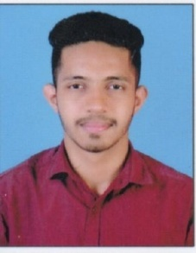

CARREER OBJECTIVE

To secure a challenging and professionally satisfying career with a potential for professional advancement in a highly competitive environment. Looking for an opportunity where I can achieve my objective thereby playing a significant role towards the growth of the organization with my hard work and commitment.
Personal Strength :

- Good and fast learner.
- Good communication and interpersonal skills.
- Determination and Hardworking.
- Curiosity and Persistence
- Flexible to new environment.

WORK EXPERIENCE

Worked as a Salesman in Mangalore for 2 years.

- Worked as Office boy in Bangalore for 1 year.
- Worked as drive in Company.

STRENGTHS :

- Maintain sale transaction, sale register of the company
- Ability to group new concepts and technologies.
- Stock manual & computer
- Office managing and co-ordinate all staffs
- Ability to effectively communicate.

PERSONAL PROFILE

Date of Birth : 03/09/1997

Gender : Male
Marital Status : Single
Religion : Muslim
Nationality : Indian
Languages Known : English, Hindi, Kannada and Tulu.

DECLARATION:

I hereby declare and affirm that all statements made in this application are true, complete and correct to best of my knowledge and belief.

