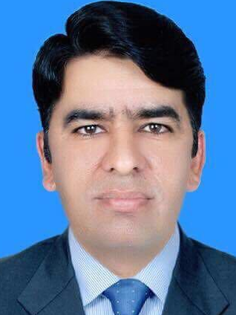
360835@gulfjobseekers.com

EXPERIENCE  Medina Dairy LTD UK  From January 2012 to March 2016.  2)Riphah International University  From October, 2010 to July 2011.  3)Nasirabsar & Co.(Pvt.) Ltd. Islamabad  From Jan, 2009 to Oct,2010  Non Profit Organizations  Health sector  Qualification  Computer Skills:  Reference: | OBJECTIVE:  To explore my energies and talent for achieving self-realization, to satisfy appetite for challenges and considerable practical experience across the, internal audit function, finance function, particularly in financial accounts, customer services, development & re-engineering of systems.  To contribute towards the growth and development of a dynamic organization where opportunities to grow both professionally and personally are ample.  PROFESSIONAL PROFILE:  - Performance-driven, professional with 5+ years of continuous advancement  - Expertise in auditing and accounting.  - Proactive self-starter with track record of initiative, personal responsibility, ownership of work and reputation for removing obstacles and making things happen.  - Computer-literate performer with extensive technical proficiency covering wide range of applications and platforms, including MS Excel, MS Word and MS Office.  AREAS OF EXPERTISE:   Auditing  Financial Statements   Inventory Audits  Records Examinations   Accounting Software  PROFESSIONAL EXPERIENCE:  Accountant  - Prepare Sale Budget; allocate salesman wise targets and analysis negative variance if any.  - Preparation of payment detail documents (Delivery Challan, Bills, Purchase requisition, Purchase Orders and GRIRS.  - Monitoring Trade Receivables/ Payables.  - Customer/ Supplier Analysis.  - Customer Satisfaction analysis  - Cash/ Cheque Disbursement.  Finance Officer  - Preparation of bank “reconciliation statement.  - Preparation of Financial Statements.  - Preparation of payment detail documents (Delivery Challan, Bills, Purchase requisition, Purchase Orders and GRIRS.  - Preparation of Student debit advices and credit advices  - Posting of Accounting Transactions.  Audit Officer.  I have been engaged in the planning and execution of various assignments, review, evaluation, designing and documentation of policies, procedures and accounting & internal control systems.  I possess comprehensive knowledge of business, internal controls and accounting systems. I have worked on assignment of different nature i.e. Internal and External Audit.  - During my jobs I have completed the following assignments:  - Islamic International Medical College Trust for the year 2009-10.  - Riphah International University for the year 2009-10.  Pakistan Railway Hospital  Islamic International Medical Complex.  Raazi Hospital.  PROFESSIONAL QUALIFICATION:  Level 7 Diploma  Diploma in Strategic Management and Leaderhip from Edexcel UK  MBA Finance  From National University Of Modern Languages Islamabad in 2009.  MAJORS:   Investment And Portfolio Management.  Cost accounting   Financial Accounting  Business Law   Corporate Restructuring  Information Technology.  EDUCATION  - Bachelors in Commerce.  - ICS. (equivalent to A-Levels).  - SSC (equivalent to O-Levels).  SKILLS, TRAINING AND COURSES:  - I have excellent work experience and knowledge of Microsoft Office and I am quite adept at Microsoft Excel and Word.  - Working Knowledge Of CMS (Campus Management System).  - I am fully conversant with the use of ‘Peachtree’ and used it as office tool.  - Installation of various types of operating system like Windows and other computer softwares.  Will be furnished upon request.

