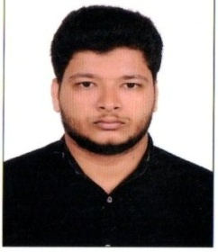

Naseehulla
Naseehulla.360913@2freemail.com

OBJECTIVES
Seeking a challenging and responsible position in an enterprising organization where opportunities exist for innovations knowledge enhancement and professional growth.

SKILLS
- Very Energetic and organized
- Efficient and well behaved
- Able to work under pressure of work and with the other workers as on team
- Skill in planning analyzing and coordinating activities
- Willingness to take up & fulfill challenges.
- Self Starter & Analytical in nature.

EDUCATION QUALIFICATION
- Secondary School
- BA Arabic (not complete)

OTHER QUALIFICATIONS

- Desktop publishing (DTP) in English and Arabic language
- Certificate in Arabic Urdu language at government of india
- Certificate in oral translation In Arabic to Malayalam at college

BASIC COMPUTER SKILLS

- MS office
- Photoshop
- Hardware & software
- Internet handling

EXPERIENCE

WORKED AS A:
- Emirates id center @ UAE
- Typing center @ UAE

Arabic English Type Writer

Arabic Teacher
- Arabic Malayalam Translator
- Computer Service Foreman
VISA STATUS
Employment visa
LINGUISTIC ABILITY
English
Arabic
Urdu
Malayalam
Hindi
DECLARATION

I hereby declare that the above mentioned details are true and accurate in best of my knowledge.

