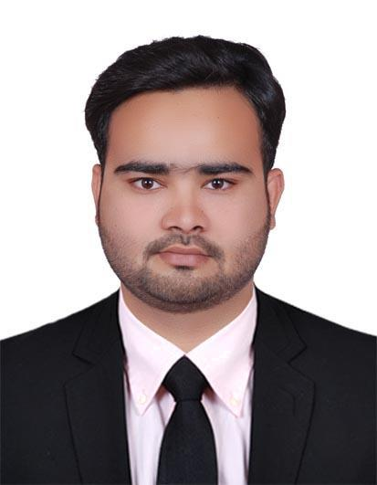

Mohammad
Mohammad.360915@2freemail.com

Summery :-

- Self motivated and well organized professional with substantial experience and outstanding skills in Accounting, with 3 years of experience in Central Private Hospital in Sharjah; being able to complete the assigned task within the given time frame with accuracy, excellent interpersonal skills, hard working and results-driven attitude.

Education :-

- Bachelor of Commerce :C.S.J.M. University Kanpur India.

Work Experience :-

  - As An Assistant Accountant (Accounts & Insurance ) From December 2013 till present ( Central Private Hospital ( Sharjah ) –

- As Reconciliation supervisor( Insurance )

Responsibilities :-

- Posting of Entries in ERP software ( Bank receipt ,Bank payments, Contra entry &petty cash ).

- preparing monthly ledger of advances, leave salaries & air ticket of the staff.

- Posting all supplier payments and customer collections.

- Matching invoices against delivery notes.

- Preparation of Cheque.

- Monthly reconciliation with bank statement.

- Handling petty cash.

- Handling cash flow and arrangement of funds.

- Billing & submission of Credit companies.

- Follow up with Insurance companies.
- Insurance reconciliation.
- Preparing monthly ledger of Insurance payments received.

- Resubmission of the insurance invoices.

- Insurance invoice settlement.

- Reconcile and rectify insurance ledger account.

Professional Skills :-

MS Word, Ms Excel, Work in any software.

Languages :-

English , Hindi & Urdu.

