Benson
Benson.360925@2freemail.com
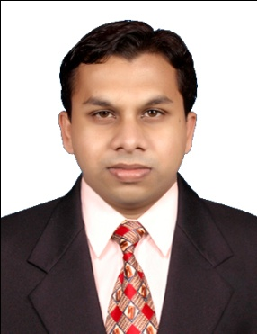

Career Objective
To be a part of a professional organization and work in a co-ordinated andgoal oriented ambience. To be at a platform where I have the opportunity to utilize my expertise and to
the best of my ability. Am personally influenced to constantly built on knowledge and
Implement and develop my existing skill. I wish to pursue a career that would provide me
with constant challenges and experience and develop with the company and team I work
with.

Professional experience
Name of the company : AlulineEnvironmental Services L.L.C,
Dubai, UAE.
Designation : Sales & Survey Engineer
Duration : 2013 October – 2015 November

RESPONSIBILITIES

- Supervise the area for the installation of the Interceptors and also resolve quires and problems of the Site Engineers
- Plan, analyze and implement budget of the particula
- Examine different designs made by the draftsmen and suggest methods to improve and implement the same
- Study the design contract and documents submitted and finalize the project after reporting to the team head
- Re arrangements in accordance with the client's requirements and the organization's budget
- Guidance to the installation Team
- Monthly routine visits who owns an AMC
- Providing staff training

Name of the company :Falcon Technologies International L.L.C,
Ras Al Khaimah, UAE.
Designation : Senior Line Incharge
Duration : 2009 September-2013 October
Product Manufactures :Dvd,Cd,and Blue ray discs.

RESPONSIBILITIES

- Consistently meet the day-to-day production target of the line, in close contact with QC, Dye lab, IMM and Process.
- Manage the line with the best OEE by putting the best effort and coordination with supporting departments.
- Monitor line performance, Work quality, machine condition. Help other team members to understand SOPs.
- Take care of the supervisor’s responsibilities in case of absence. Support the supervisor for resolving chronic issues on shop floor.
- Ensure data entry in cost management system. Train new team with prior experience.
- Ensure perfect conditions of 5S in shop floor and machine.
- Coordinate Six Sigma activities on shop floor to improve work force efficiency and impose strict compliance to ISO and safety system.
.

Name of the company : Lazar Diesel Engineers.
Thoppumpady ,Cochin 5.
Designation : Marine Electrician
Duration : July 2007-January 2009

RESPONSIBILITIES
.
- Servicing of Marine Electrical Equipments
- Preventive Maintenance

Academic profile
- Masters in Business Administration (2014-2016)
(Production & Industrial Management)
Ariston School of Business Studies (Ernakulam)
- Bachelors Program in Business Administration (2011-2014)
Ariston School of Business Studies (Ernakulam)
- Diploma in Electronics and Telecommunication Engineering (2004-2007)
Skiltek Educational Institutions (Ernakulam)
- Plus Two (Vocational Higher Secondry Education) (2002-2004)
S.D.P.Y. V.H.S.E (Palluruthy)
- S.S.L.C (2002)
C.C.P.L.M Anglo Indian High School (Thevera)

Additional knowledge
Driving License : Light Motor Vehicle (UAE)
AutoDesk: AutoCad
Computer proficiency : MS Office-WORD, EXEL & INTERNET
Languages known : English, Hindi, Malayalam,Tamil.

DECLARATION
I hereby declare that the above written particulars are true to the best of my knowledge.

