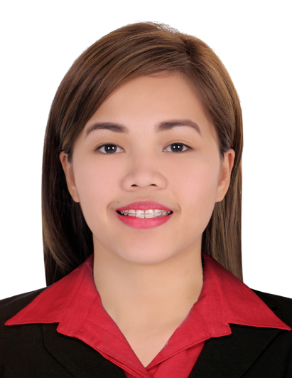

Maria
Maria.360984@2freemail.com

OBJECTIVE:

To obtain a challenging and responsible role of a full time nurse where my extensive nursing and medical background, professional and practical experiences will be utilized.

SUMMARY OF SKILLS

Dialysis Nurse
•Operates and troubleshoots of Fresenius Machine 4008 S and 5008S Hemodialysis Machine
•Assesses, identifies and handles different access like AV fistula, AV Gortex/Graft, Intra Jugular Catheter, SubClavian Catheter and Femoral catheter
•Performs Safety Check: Primed Bloodlines and Tested machines, Couplings on place, integrity of dialyzer whether first use or re use.
•Priming blood lines, skin preparation and inserting dialysis needle into arteriovenous fistula and arteriovenous graft aseptically.
•Ensures that both temporary and permanent catheters are cleaned properly.
•Takes and records patient’s vital signs on a regular basis.
•Initiates, maintains and terminates Hemodialysis treatment.
•Evaluates patient’s reaction to dialysis procedures and make sure that each observation is documented properly.
•Operates and Troubleshoots ADR-88 and Renatron Dialyzer Reprocessing machine
•Able to establish rapport with either local or foreign patients
•Responds to emergency situations during dialysis procedures.

Bedside Nurse
•Maintains safety and precaution standards
•Reports patient’s condition to appropriate personnel during each shift.
•Documents patient’s assessment findings, physical/ psychosocial responses to nursing intervention.
•Maintains confidentiality in matters related to patient, family and facility staff.
•Initiates emergency resuscitative measures according to pediatric and adult protocols.
•Assists physicians during examinations and procedures.
•Administers medications, carry out treatments and procedures
•Monitors and records vital signs accurately
•Performs NGT and PEG tube feeding, Suctioning of secretions either per orem/ tracheostomy or via endotracheal tube
•Performs NGT insertion, foley catheter insertion, IV cannulation and CBG monitoring
•Assists patient in nebulization and oxygenation
•Hooking patient to Cardiac Monitor
•Initiates, maintains and terminates Blood Transfusion and assesses post BT complications

CORE QUALIFICATIONS

•Ability to operate dialysis equipment
•Profound knowledge of dialysis procedure
•Strong ability to collect and evaluate patient’s data
•Readily developed rapport with patients, families, staffs and other care professionals
•Ability to multi-task effectively
•Ability to communicate with Filipino and English speaking clients.
•Literate in Microsoft Office, BizBox8 and Hospital Information and Management System

WORK HISTORY

Name of Hospital: BATANGAS MEDICAL CENTER
Address: Bihi Road, KumintangIbabaBatangas City, 4200 Philippines
Bed Capacity: 250 beds
Unit: Medical-Surgical Ward
Duration of Employment: January 2013- December 2013
Position: RN Heals (Registered Nurse for Health Enhancement and Local Services)

Name of Hospital: MARY MEDIATRIX MEDICAL CENTER
Address: JP Laurel Highway Lipa City Batangas, 4217Philippines
Bed Capacity: 174 beds
Unit: Medical-Surgical Ward
Duration of Employment: November 2014- June 2015
Position: Staff Nurse

Name of Hospital: MARY MEDIATRIX MEDICAL CENTER
Address: JP Laurel Highway Lipa City Batangas, 4217Philippines
Bed Capacity: 179 beds
Unit: Hemodialysis
Duration of Employment: July 2015 – February 2017
Position: Staff Nurse

TRAININGS & SEMINARS ATTENDED

3 Days Basic IV Therapy Training
September 2012
LilianMagsino Hall, Mary Mediatrix Medical Center, Lipa City, Philippines

The myths and facts about CKD/ESRD
July 28, 2014
LilianMagsino Hall, Mary Mediatrix Medical Center, Lipa City, Philippines

Multi-filtrate CRRT Machine Operations Training
December 17, 2015
Mary Mediatrix Medical Center Lipa City, Philippines

Advanced Cardiovascular Life Support (ACLS) Course
July 3 2016
UST-FMS Support Training Center, Philippines

6th Hemodialysis Postgraduate Course
Hemodialysis in Special Patient Populations & Situations
August 14, 2016
Summit Ridge Hotel, Tagaytay, Philippines

EDUCATION

Graduate Studies St Jude College Manila
Master of Arts in Nursing Don Quijote St. Sampaloc, Manila
2013- 2014
Prevalence of Nosocomial Infections post-surgery among patients confined in Batangas Medical Center: Basis for Quality Improvement

Tertiary
Bachelor of Science in Nursing De La Salle Lipa
2008 – 2012 Lipa City, Batangas, Philippines
Secondary: St. Bridget College
2004 – 2008 Batangas City, Philippines

