Shara
Shara.361075@2freemail.com

SalesExecutive

AcquiredyearsofexperienceinsalesandMarketing.

Aself-motivatingwithentrepreneurialmanagementskilshavingyearsofqualitative experienceinsales,marketingandbusinessdevelopmentinPhilippinesmarkets.

Aprovenexecutiveinacceleratinggrowth,producingclients’loyaltylevelsandrendering

Retailandcorporatesectorcustomereffectively.
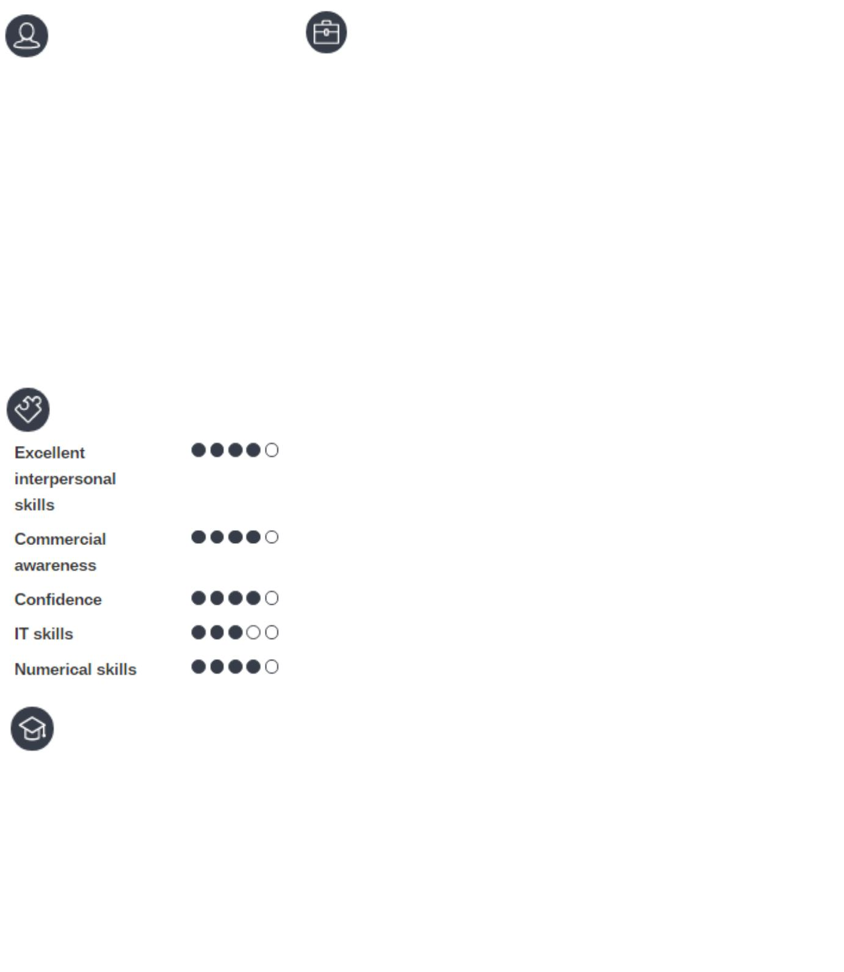

 |  |  | Experience
 |  |  | SalesExecutive
 | 2016-03- |  | AlsonsTrading
 | 2016-10 |  | •Maintainingrelationshipswithexistingcustomers
 |  |  | throughregularvisits
 |  |  | •Convertingsalesthroughfacetofacesales
 |  |  | negotiation
 |  |  | •Managingthekeyaccountsandanalyzingthe
 |  |  | salesthroughthecompany
 |  |  | •Launchednewproductsandproductranges
 |  |  | •Establishandmaintainbusinessrelationsand
 |  |  | generatenewbusiness
 |  |  | •Ensurehighlevelofconsumersatisfactionby
 |  |  | buildingandmaintaininggoodrelationshipswith
 |  |  | potentialcustomers
 |  |  | •Verifyingthedocumentsandsubmitingwith
 |  |  | 100%successratio
Skils |  |  | •Initiateandclosedeals
 | 2016-11– |  |  | SalesExecutive
 | 2017-03 |  |  | MSSDrivingSchool
 |  |  |  | •Proactivelyacknowledged,greetedandassisted
 |  |  |  | customersinthestore
 |  |  |  | •Offeredcustomerswithexemplaryandtimely
 |  |  |  | service
 |  |  |  | •Providedaccurateproductinformation
 |  |  |  | •Enhancedproductknowledgeutilizinglimited
 |  |  |  | resources
 |  |  |  | •Maintainedworkingknowledgeofstore’spolicies
 |  |  |  | andprocedures
 |  |  |  | •Handledcash,checks,andcreditcard
 |  |  |  | transactions
Education |  |  |  | •ManagedtheregisterinaccordancewithPOS
 |  |  |  | guidelines
 |  |  |  | •Addressedlosspreventionissuesimmediately
UniversityofNorthernEasternPhils |  |  |  | •Communicatetocoworkersandsupervisors
BachelorofElementaryEducation |  |  |  | throughstandardtelephoneandwirelessaudio
SY2012-2014 |  |  |  | systems
 |  |  |  | •Builtandmaintainedinternalandexternal
AMAUniversity |  |  |  | customersatisfaction
BachelorofScienceinInformation |  |  |  | •Metandexceededsalesgoals
Technology |  |  |  | •Upheldbrandandoperationalstandards
SY2014-2016 |  |  |  | •Assistedsupervisorstoidentifyandresolveissues

