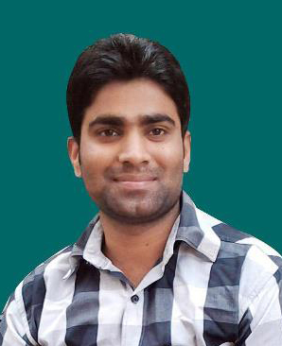
Narendra
Narendra.361082@2freemail.com

Educational Qualification:
- High School form S.H.S.S. Jatepur RLY Colony Gorakhpur U.P. Board
- Intermediateform Saraswati Intermediate College Naharpur Gorakhpur U.P. Board
Technical Qualification:
DCA Diploma in Computer Application
(M.S. Office) – M.S. Word, M.S. Excel, Power point
CorelDraw, Photoshop, PageMaker, Tally 9
Successfully from Sunrise computer Institute, Chargawan, Gorakhpur

Computer Typing:
Hindi & English
Personal Details:
Sex : Male
Nationality : Indian
Marital Status : Unmarried
Hobby : Reading, Playing
Working Experience:
In CorelDraw, Photoshop, PageMaker, Tally9, Hindi Typing, English Typing 10 Years from Global Net Printing Press, Om Sai Printing Press, Amrapali Press, Drishti Press, NGO PGSS

