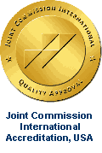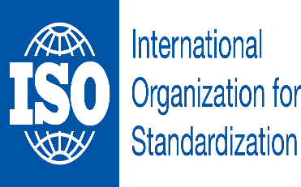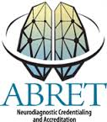

SAMREEN
SAMREEN.361105@2freemail.com

Objective:
To make a leading career in a growth oriented organization and utilize my capabilities and education by providing best possible services for the organization and community.

Academic Achievements:

August 2013 – 31 July 2015
On job training in neurophysiology technologist in Clinical Neurophysiology Department at The Aga Khan University Hospital, Karachi Pakistan

2010 M.A (Political Science)
University of Karachi, Pakistan.

2005 BSC (Zoology)
University of Karachi, Pakistan.

2002 F.SC Sir Syed government girl’s college Karachi Pakistan

2000 SSC
Sultan Mohammad shah Aga khan school Karimabad

Experience

- Currently working as a neurodiagnostic Technologist at Clinical Neurophysiology Aga khan university hospital Karachi Pakistan from 01 august 2015 to up to date.

PROFESSIONAL QUALIFICATION:
Successfully cleared part 1 of American Board of Registered Electro-Diagnostic Technologist (ABRET) in November 2016.

Training:
- Conducting and interpreting EEG, NCS, EP and PSG
- Currently Responsible for performing procedure on latest Digital machines

- Electroencephalography (EEG)
- Routine Electroencephalography
- Sleep Deprived Electroencephalography
- Video Electroencephalography monitoring (VEEG)
- Long Term Electroencephalography Monitoring

- Sleep Studies (Polysomnography)
- Polysomnography
- Multiple Sleep Latency Test
- Split night Polysomnography

- Evoked Potentials (EP’s)
- Visual Evoked Potentials (VEP)
- Auditory Evoked Potentials (BAEP)
- Somatosensory Evoked Potentials (SSEP)

- Nerve Conduction Studies (NCS)
- Performing Nerve Conduction Studies
- Assist Neurologist in performing needle EMG study
- Autonomic neurophysiologic testing

Acquainted Machines and Neurophysiology Software
EMG/NCS & Evoked Potentials:
- Neuropack M1 of Nihon Kohden Corporation, Japan.
- Viking Quest of Viasys Healthcare
- Neuropack Sigma of Nihon Kohden, Japan

Digital EEG:
- Neurofax of Nihon Kohden Corporation, Japan.
- NicVue of Viasys HealthCare.
- Nicolet One VEEG of Viasys Healthcare
- Digital EEG System of MedEX Co.

Ambulatory EEG:
- Nicolet One Ambulatory EEG of Viasys Healthcare

Polysomnography:
- Neurofax of Nihon Kohden Corporation, Japan.
- Nicolet One Sleep of Viasys Corporation.
- Sleep Diagnostic System of MedEX Corporation

Certificates and courses:

Attended workshop on “Power lab and LAB tutors: Tools for basic Neuroscience Teaching and research”, 2013.
Attended workshop on Neurophysiology Dept., 2014

Basic Life Support in accordance with American Heart Association
Valid from 14 October 2015 to 14 October 2017 at the Aga Khan University Hospital Karachi. Pakistan

ENGLISH CONVERSATION COURSE:
Attended A Seven Months Course of English Conversation by NOOR-E-KARIM English Language Centre.

COMPUTER COURSE:
Completed Three Months Course of Microsoft Office 2000 Successfully.

VOLUNTRY SERVICES:

Completed Three Months of Voluntarily Service at Aga Khan University Hospital at Family Medicine Department. My Responsibilities were as a secretary. Responsibilities include:
- To Maintain Filing System, Typing and Reports
- Also, Kept Follow-up for The Meetings of Doctors and Give Reminders.
- Open and Distribute Incoming Regular and Electronic Mail, Answer Telephone Calls and Messages.

Also, Completed Two Months of Voluntarily Service at Finance Department.

Skills:
MS Word 2010, MS PowerPoint 2010, MS Excel, MS Outlook, Custom Organizational Software

Strengths:
- Strong verbal and written communication skills.
- Excellent communication, interpersonal and co – ordination skills.
- Team leadership
- Successfully completed IELTS general training test by getting 7 bands.
- Excellent speaking power in English
- Ability to work under pressure
- Strong presentation skills
- Fast learner with an ability to excel

Reference
Will be provided on demand.

