Krishnaprasad
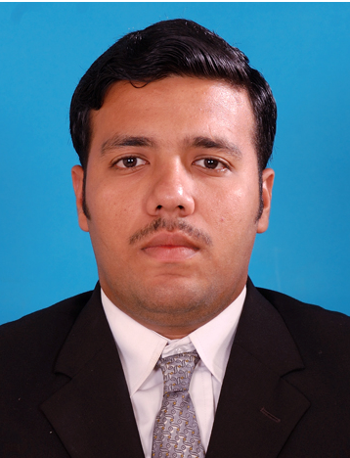
Krishnaprasad.361122@2freemail.com

PROFESSIONAL EXPERIENCE
LANGUAGES KNOWN
English: Spoken & Written
Malayalam: Spoken & Written
Hindi: Spoken & Written
Tamil: Spoken
Kannada: Spoken
Time Period | Organization | Experience Summary
Apr 2010  to Aug 2011 | Hindustan Aeronautics Ltd.,  Bangalore, India | 1 year On-Job-Training - working experience in Aircraft Maintenance & Engineering  Looking for a challenging position within a growthoriented company that will utilize my skills and experience to their full potential and will lead to progressive career growth.
2012  to 2013 | Atria Star Hotel, Bangalore,  India | 3 months working experience in 5 star hotel as chef
Oct 2015  to Jan 2016 | Concentrix Daksh Services India Pvt Ltd, Delhi, India | PractitionerCRM Operations  Telemarketing & Call Centre services for Amazon, etc  IT SKILLS PROFICIENCY  Microsoft Office:  Word / Excel / PowerPoint
Ongoing | 'Siva Darsana' Family Restaurant Business, Kerala, India | Over 15 years first hand practical experience in managing and running all aspects of family catering &restaurant business

ACADEMIC QUALIFICATIONS
Year | Qualification | Instituition | Details
2005 | 10th Std | Board of Kerala | Passed with 70%  As is evident from the CV, I’ve worked in varied industries and handled various job profiles over the course of past 15 years and now hope to settle and focus on one line of career stream.  I’m young, energetic, flexibleand with absolutely no hang-ups on the kind of work that needs to be handled. And I’m very eager to perform successfully & satisfactorily in every role entrusted to me.  My ideal career opportunity will be one which gives me ample opportunities for the following:  - Room for creativity  - Meet new people  - Employ problem solving skills  - Face new challenges  - Progressive opportunity for personal & professional growth
2007 | 12th Std | Board of Kerala | Passed with 67%
2010 | AME  (Aircraft  Maintenance  Engineering) | Southern College of Engineering & Technology, Chalakudy, Kerala. | Passed with 78%  Approved by DGCA (Director General of Civil Aviation, India)
2014  to 2015 | Hotel Management (Food Production) | Food Craft Institute (FCI), Kerala, India | Passed with first class & distinction

OTHER VOCATIONAL QUALIFICATIONS
Year | Qualification | Instituition | Details
2004 | Certificate of Diploma in Computer Application | Cyber World Computer Education, Kerala, India | Passed with A grade
May 2005  to Jul 2005 | Electronics & Computer Certificate Course | ACE Computer Education & College of Engineering, Kerala, India | Successful Completion & Certification
Jan 2012  to Feb 2012 | Personal Enhancement & Grooming | BSAS India Ltd & Soft Skills World | Successful Completion & Certification

