ANTONY
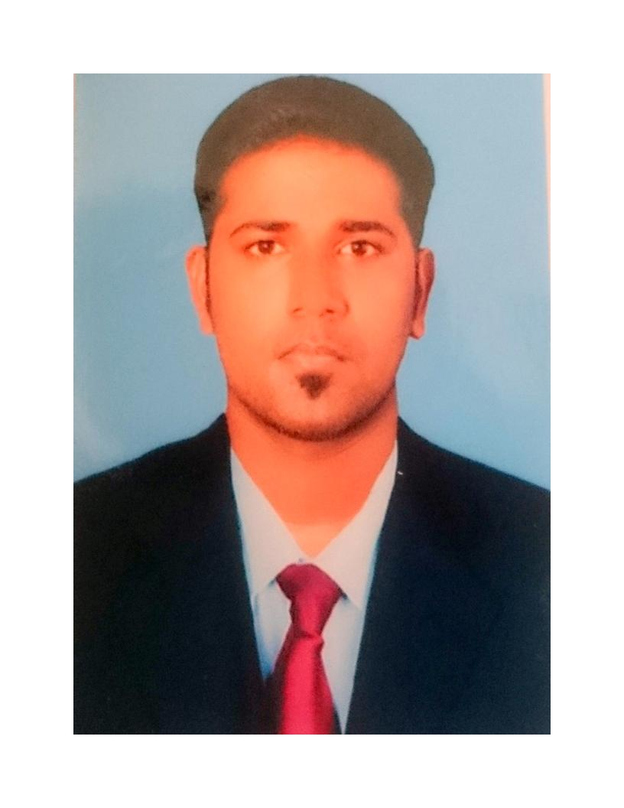
ANTONY.361125@2freemail.com
Bachelor of Engineering (Electronics and Communication)
Address: Doha Qatar.
Nationality: Indian
Visa Status: Residence visa
Summary:

Skilled at administering large production Ecommerce environments varies windows environments (Active Directory, DNS) and IIS, load balancing for high availability networks. Provided network support, for development, test, and production environments, installed, configured, and administered network servers for corporate and co-located data centers in high availability e-commerce environments. Have strategic and analytical ability in minimizing down time of technical problems. Strong organizational skills with commitment in creating effective documentation of IT issues for cross training. Solid leadership skills with experience serving as team/project lead on numerous occasions.
Work Experience:

Company 5: SIEVERT INTL INSPECTION WLL. JUN 2016 – Till date
Role: IT Administrator
- Maintained PCs including servers, workstations, laptops, printers, and multimedia equipment. Windows 2008 server administration
- Manage frame relay and multiple T1's between offices and vendors via various routers and switches. Outlook Web Access.,Antivirus updation Macfee Client, IBM Lotus notes,Jwalk, AS400, Junniper firewall systems, symantec Backup,ip phones.
- Troubleshooting of PCs, printers, scanners, Fax machines and.
- Responsible for new installations of any servers as well as new operating systems and software

- IT helpdesk request checkin, ticket raising for new employees locally.

- World checkin, Hris platform,Nitro, BlackBerry mail configuration, IT asset maintaining,dealing with local distributers for accessories.

Company 4: Annai Veilankanni’s college of Engg, INDIA DEC 2015 - MAY2016
Role: IT Admin
- Design and maintain network infrastructure (LAN/WAN, DHCP, DNS, Firewall and router configurations. Domain account, file and printer security administration
- Windows 2008 server administration, Desktop/End-user support,
Internal/external network security, auditing and response, Implement and secure wireless network.
- Data backups and maintaining.
- Troubleshoot problems with Nt and Exchange server.
Company 3: BUREAU VERITAS QATAR IT Admin Trainee SEPT-OCT 2015
- Handled Microsoft windows server 2008 & 2012 administrator.
- configuring and installing lotus notes IBM As400 client.
- knowledge in Cisco systems juniper, jabber Jwalk/zig for financial module etc.
- Account creation and maintained of AD users, groups, sharing and permission.
- Knowledge in IP phone handling.
- Troubleshooting of PCs, printers, scanners ,Fax machines and IP phones.
Company 3: HANSA DIRECT PVT, INDIA SEPT 2014 –JUNE 2015
Role: Support Engineer
Responsibilities:
- Managed a helpdesk environment of 2 servers with 96 users and responded to tickets within 24 hours Applied and continuously adapted network access and group policies to enhance network security Monitored a VMware environment of hosts for performance
- Providing technical lead, support, pre-sales & project management services to achieve the IT goals of both short & long term projects involving WAN, LAN and/or computer integrations.
Company 2: NITTANY CREATIVE SOLUTIONS, INDIA APRIL 2013 –MAY 2014
Role: Support Engineer
Responsibilities:
- E-Mail Client Configuration & Support (Microsoft Outlook and Outlook express) Windows 7, Vista and XP professional Client Operating Systems
- Knowledge over LAN technologies like VLANS, VTP, Inter VLAN Routing, VLAN
- Enhanced Security Features like DHCP snooping, Port Security
- Sound knowledge on IP addressing schemes
- Experience with Windows XP / VISTA / Windows 7.
- Experience with MS Office Packaged and Mail Clients.
- Good knowledge about Active directory, DNS and DHCP.
Company 1: Sheraaj Food & Beverages PVT INDIA April 2012 – March 2013
Role: Desktop support engineer
Responsibilities:
- Install, upgrade, support and troubleshoot Windows OS, authorized desktop applications, hardware, and peripheral equipment.
- Return defective equipment to maintenance inventory, document customer repairs, and maintain and restock parts inventory to maintain spare parts levels.
- Monitor, operate, manage, troubleshoot, and restore service to terminal service clients, PCs, or notebooks with authorized access to network.
Technology skills :

Certificate Course in MCITP and MCTS from CMS Computer Institute,Banglore,INDIA
Microsoft Certified IT Professional
Installation of Windows 7, Windows Server 2003/2008 R2
Maintenance of Active Directory Users and Computers Console
Maintaining Standards for Usernames, Passwords, System Resources, Storage Organizations, etc
Managing Group Policy Objects and users
Creating Organizational Units
Monitoring Antivirus Updates
Operating System : Windows XP, Vista, Windows 7,8,10 server 2008.
Software/packages : MS Office2003/2007/2010, VM ware.
Education:

B.E (Electronics and Communication) (2008-2012)(6.1CGPA)
Cape Institute of Technology, Thirunelveli, INDIA

Higher Secondary School (2008) with 59 %
VKP Higher Secondary School, Colachel, INDIA

Seminars/Papers/Certifications

Certificate 1: 2nd Place for Project Expo in N.I. Engineering College, TamilNadu, INDIA.
Certificate 4: In plant Training: “Fundamental of telecom”, BSNL, TamilNadu, INDIA.
Certificate 5: MCITP (Microsoft certified IT professional), CMS, Bangalore, INDIA.

Certificate 6: PHP,GIIT ,TamilNadu , INDIA.

Personal Profile

Age & Date of Birth : 18th Jan 1991
Hobbies & Interest : surfing, Tech news, Keeping Pets, Listening to Music.
Strengths : self-starter, Flexible & Adapting, Leadership.
Mother tongue : Tamil
Other Languages Known : English, Malayalam, Hindi (Speak)

Declaration:
I hereby declare that the information furnished above is true to the best of my knowledge an belief.

