361127@gulfjobseekers.com
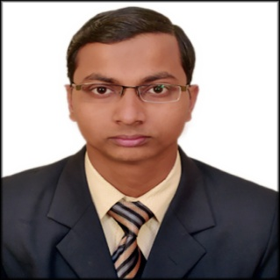
CAREER OBJECTIVE

- To enhance and use my abilities in order to provide the best possible advantages to the organization by virtue of my presence. Excel in the field of engineering with the help of consistently improved skills, updated knowledge and talent and by performing activities in the technical discipline for the benefit of the company and my career.

YEAR | DEGREE/CERTIFICATE | % | INSTITUTE (UNIVERSITY)
2016 | Bachelor of Technology in  Mechanical Engineering | 76.12 | AZAD INSTITUTE OF ENGG. & TECHNOLOGY (AFFILIATED TO DR. APJ ABDUL KALAM TECHNICAL UNIVERSITY),LKO
2011 | INTERMEDIATE | 78 | SEVENTH DAY ADVENTIST SR. SEC. SCHOOL (ISC BOARD),LKO
2009 | HIGH SCHOOL | 73.2 | SEVENTH DAY ADVENTIST SR. SEC. SCHOOL (ICSE BOARD),LKO
EDUCATIONAL QUALIFICATION

SUMMER TRAINING
- Topic : Working of Expressor and their parts and testing.
- Place : Locomotive workshop Charbagh,Lucknow.
PROJECT UNDERTAKEN
- Topic : STRADDLING BUS – A bus having the width of two traffic lanes and sits high above the road surface, on a pair of fencelike stilts that leaves the road clear for ordinary cars to pass underneath it.

COMPUER LITERACY

- Microsoft Word, Microsoft Powerpoint
- Internet
TECHNICAL SKILL
- HVAC course from 6th June to 20th July,2016.
- AutoCAD course from June to July,2014.

STRENGTHS
- Always adaptive to the working environment.
- Quick learner.
- Believes in doing work honestly, sincerely, effectively.
AREA OF INTEREST

- HVAC
- Production Technology
- Automobile Engineering
- Design
- Thermal Engineering

