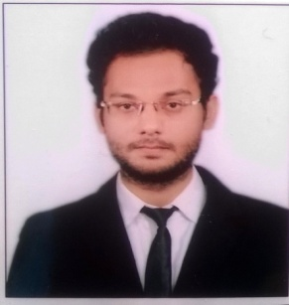Faiz
Faiz.361133@2freemail.com

OBJECTIVE
To work in a result oriented organization that seeks an ambitious and career conscious person where acquired skills and education will be utilized towards mutual growth and advancement of both the organization and me.
EDUCATION
Completed Bachelor of Technology in Civil Engineering from Integral University, Lucknow , May, 2015.
YEAR | DEGREE/CERTIFICATE | % | INSTITUTE (UNIVERSITY)
2015 | B TECH (CIVIL ENGINEERING) | 60.89 | INTEGRAL UNIVERSITY
2011 | INTERMEDIATE | 68 | SEVENTH DAY ADVENTIST SR. SEC. SCHOOL (ISC)
2009 | HIGH SCHOOL | 72 | CATHEDRAL SR. SEC. SCHOOL  (CBSE)

EXPERIENCEWorked as a trainee civil site engineer for JRS CONSTRUCTIONS,
From 20th August,2015 to 1st July,2016
RCC WORKS, REINFORCEMENT DETAILS, CONTRACTORS BILLING, LAYING OF TILES.
SKILS & TRAININGS
- PROJECT ON ANALYSIS AND DESIGN OF COMMERCIAL BUILDING .
- PRE FINAL YEAR TRAINING FOR 4 WEEKS IN UTTAR PRADESH RAJKIYA NIRMAN NIGAM (RCC works of Rajya Sochna Ayog Building; Lucknow)
- AUTO CAD COURSE IN JUNE - JULY 2014

ACHIEVEMENTS & AWARD
- PARTICIPATION IN TECHNICAL PAPER PRESENTATION

- TRAINING COURSE ON "AQUIFER MANAGEMENT THROUGH PARTICIPATORY APPROACH AND LOCAL GROUND WATER ISSUE"
EXTRA CURRICULAR ACTIVITIES
- IST PRIZE IN NUKKAD NATAK IN FEASTA 2014
SUBJECTS OF INTEREST
- GEOTECHNICAL / SOIL ENGINEERING
- CONCRETE STRUCTURE
- CONCRETE TECHNOLOGY
- ENVIRONMENTAL ENGINEERING
- FOUNDATION
- BUILDING MATERIALS AND CONSTRUCTION
COMPUTER PROFICIENCY
• JAVA
• MICROSOFT WORD
• HTML
STRENGTHS
- Sincerity & punctuality
- Positive attitude
- Hard working nature
DECLARATION
I hereby declare that above mentioned information is true and correct to best of my knowledge.

