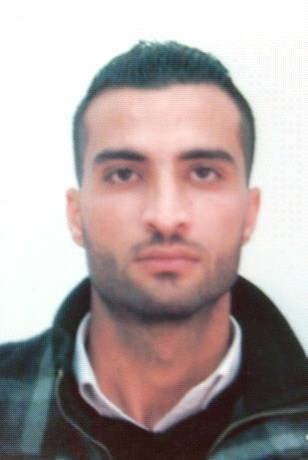

CURRICULUM VITE

Zaha

Location: Dubai, United Arab Emirates

Education: Bachelor's degree

Employment Type: Employee

Employment Status: Full time
Career Level: Mid Career
Notice Period: immediately
Country: Dubai, United Arab Emirates
Email Address: zaha.361146@2freemail.com

Objective

I am hardworking person and always take keen interest with people who believe in team work. I would like to avail a challenging position within your company for career advancement and explore how my capabilities may be utilized to meet the expectation of your company. Should my particular meet your requirement, I will be very delighted to a position which may consider me suitable. I am available to join immediately and would appreciate if I would be given opportunity to be considered as one of the member of your team.

Personal Information

Birth Date: 16 Sep 1988 (Age: 28 )

Gender: Male
Nationality: Jordanian
Location : United Arab Emirates
Visa Status:expire

Marital Status: Single

Experience (5 Years, 5 Months)

Customs Clearance

Alsaid automobile trading fzco Location: Dubai - ALaweer free zone - United Arab Emirates

Company Industry: export and import cars

Job Role: Customs Clearance Dubai trade – mirsall 2 ( Aug -2013 / April – 2017)

Key Responsibilities:

1- Delivery advice , packing list , bill of loading , trade license , Commercial Invoice, Certificate of Origin for shipment

2- Transit in , Transit out , import to local , import for local to free zone , export from local to free zone , export from local to free zone after temporary ,

3- Temporary admission from local to free zone ,

4- Claims , refund of deposits , refund of Duty ,

5- initiate inspection , initiate inspection with clear declaration , control for inspection request ,
6- Amendment Declaration : Transit in , Transit out , Import , Export , Temporary , transfer with free zone

7- Cancel Declaration : Transit in , Transit out , Import , Export , Temporary , transfer with free zone

8- Transit in , Transit out , Import , Export , Temporary , transfer with free zone

9- Submission for Documents : Transit in , Transit out , Import , Export , Temporary , transfer with free zone .

Customs clerk

Alnahda Forwarding and CLearing Co , Location: Abu Dhabi - AL Ghuwiafat port - United Arab Emirates

Company Industry: Shipping and Clearance
Job Role: Customs clerk (July 2012 - May 2013)
Key Responsibilities:

Print customs data and follow-up clearance on the one hand the release of the next shipment and problem-solving of the customs duties imposed by customs in terms of reduction of the value that is evaluated by the evaluation and guarantee the Customs Department in the case of export cargo for both outside and inside the country with a free trade zone within the country .

ACCOUNTANT

Al shamal for hajj & umrah Location : Jordan

Company Industry : tourism and travel
Job Role : ACCOUNTANT (September 2010- October 2011 )
Key Responsibilities:
1- Preparing daily reports in terms of expenses and payments
2- Receiving daily amounts of customers, whether in cash or a check payment and closing the customer's account that he was paying the full amount

3- Receipt of payment that will be paid part of the value of the required amount and load the remaining portion on the customer's account

4- Prepare the balance sheet at the end of the month

5- Preparing statements for the salaries of staff
6- collection of checks payable and contact the customer to inform him in case of late payment
7- Contact hotels and settlement of accounts in terms of the amounts booked hotels for customers

Education

Bachelor's degree

jarash private university

Location: Jarash, Jordan
Completion Date : February 2012
Grade: 71.1

Specification : Banking & Financial Sciences

Skills

MICROSOFT OFFICE : Microsoft office word – Microsoft office excel – Microsoft office PowerPoint Presentation

Languages : Arabic & English

