Ramya
Ramya.361173@2freemail.com

PERSONAL DETAILS
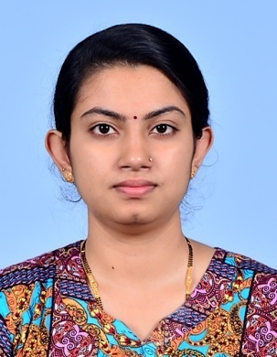
Date of Birth : 1990-07-29
Nationality : Sri Lankan
Civil Status : Married

PERSONAL SUMMARY

A confident communicator who can relate well to dental patients.Having a proven ability to ensure that dental practices in a surgery are continuously updated to provide first rate care to patients and their families.A confident healthcare professional with a long track record of successfully diagnosing and treating patients' dental conditions.Able to work as part of the dental team, and has a flexible approach to work. Looking for an opportunity to work with a forward thinking and highly regarded dental organization.

ACADEMIC QUALIFICATIONS

Bachelor of Dental Surgery, University of Peradeniya, Sri Lanka.

Graduated As Dental Surgeon on Twenty Sixth May 2016.

PROFESSIONAL REGISTRATION

Registered on 31st day of March 2016 as a Dentist lawfully qualified to practice Dentistry or Dental Surgery in Sri Lanka Medical Council.

AREAS OF EXPERTISE

- Educating patients on oral healthcare;
- Examining teeth and diagnosing patients' dental conditions by using tools such as x-rays;
- Assessing treatment options and agreeing treatment plans with patients;
- Carrying out agreed clinical treatments such as
  - Minor oral surgeries ( Extraction, Impaction,Trauma Management, Cyst Removal)
  - Basic Restorations , Root canal treatment and Crown and Bridgework
  - Orthodontic Treatment
  - Dental prosthesis
  - Scaling and root planning
- Pediatric Dentistry
- Able to write prescriptions for antibiotics and other dental medication.
- Maintaining patients' dental records;
- Recruiting, training and managing staff;
- Overseeing budgets and maintaining stocks of equipment;
- Marketing services to potential clients.

WORK EXPERIENCE - 1 Year Experience

General Dental Surgeon – Hatton,NuwaraEliya District, Sri Lanka.From 31st day of March 2016 to November 2016
Worked as General Dental Surgeon in a busy dental clinic providing a full range of dental treatment to patients to help them maintain oral health.Spending a significant amount of time standing and using specialist equipment.Working as part of a dental team, comprising of dental nurses, dental technicians and dental health educators.

Duties:-

- Providing professional dental service and care to patients.
- Examining a patients teeth and diagnosing their dental conditions.
- Dealing with routine appointments and check ups, taking impressions etc.
- Dealing with emergency cases like relieving a patients pain. Filling cavities, examining x rays, straightening teeth and repairing fractured teeth.
- Treating both adult and pediatric patients.
- Performing corrective surgery to extract teeth and replace missing teeth.
- Coordinating the surgery budgets & dealing with all aspects of financial control.
- Managing the training and development of staff.
- Updating a patients medical records.
- Diagnosing & treating conditions such as decaying teeth and gum disease.
- Reassuring anxious patients and clearly explaining procedures to them.
- Involved in dental examinations and treatments such as fillings and dental hygiene services.

PERSONAL SKILLS
- Manual dexterity and technical dental skills, plus the ability to maintain intense concentration for prolonged periods
- The ability to build relationships with patients and colleagues.
- High level communication and interpersonal skills, for interaction with patients of all ages and backgrounds.
- An interest in the welfare of others and a sympathetic manner, particularly to deal with patients' fears;
- Good administrative and managerial abilities to run a dental practice;
- Information technology skills, due to the increasing use of computers for keeping records and accounts, and for digital imaging of radiographs and intra-oral photography.

