RESUME
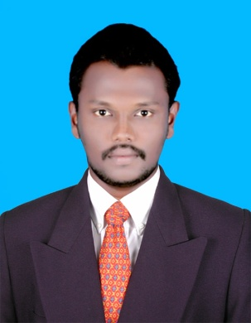
ASRAF
ASRAF.361174@2freemail.com

OBJECTIVE:
To pursue a challenging career in leading and progressive research organization offering opportunities for utilizing my skills towards the growth of the organization.

TECHNICAL PROFILE:

Course | Board/University | Institution | Duration | Percentage
M.A., (English) | Bharathidasan University, Thiruchirapalli | Annai College of Arts and Science Kovilachery | 2014-2016 | 61%
B.A., (English) | Bharathidasan University, Thiruchirapalli | Jamal Mohamed College (Autonomous)  Trichirapalli | 2009-2012 | 61%
HSC | State Board | Banadurai Hr. Sec. School Kumbakonam | 2008-2009 | 80%
SSLC | State Board | Banadurai Hr. Sec. School Kumbakonam | 2006-2007 | 44%

PROFILE
Height : 169"
Weight : 55kg
Chest : Brief- 83
Expand-88
Blood : A^{+ve}

PERSONAL PROFILE

Date of Birth : 09.06.1991
Gender : Male
Marital Status : Married
Nationality : Indian
Religion : Muslim
Language Known : Tamil & English

DECLARATION
I hereby declare all the information given above is true to the best of my knowledge.
Place : Yours Faithfully,
Date :

