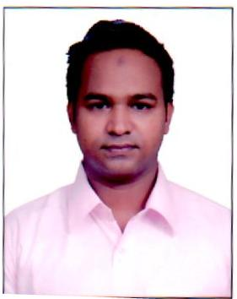
GHAYAS
GHAYAS.361213@2freemail.com

Career Objective

Independent, self-sufficient and motivated with a excel in whatever I do. I am committed to my task and do not shirk hard work. I am highly creative, adaptable and have a good sense of humor and take lots of initiatives challenges.
Personal Profile
Date Of Birth (DD/MM/YYYY) : | 30/06/1990.
Sex : | Male
Religion : | Muslim
Nationality : | Indian
Language Known : | Hindi & English

Academic Qualification
Course | University/Board | Year | %
Intermediate | U P Board | 2009 | 50.00
High School | UP Board | 2007 | 53.00

Computer Knowledge
- Basic Knowledge

Working Experience

- 3 years Experience in Store Keeper Printing and Packaging Company (POSITIVE IMAGES DELHI)
- 2 years Experience in Store Keeper AL HANOUF COMPANY SAUDIA ARBIA )

Strengths
- To Understand the Human , Excellent Communication
- Goal – Orientated , Co – Operative Nature
- Hard Working , Quick Learner
- Planning by Professionalism , Honesty & Patience
- Good Verbal & Communication Skills

Hobbies

- Music
- Reading Books & Magazines

Declaration

- I Assure that the above mentioned information is true to the best of my Knowledge.

