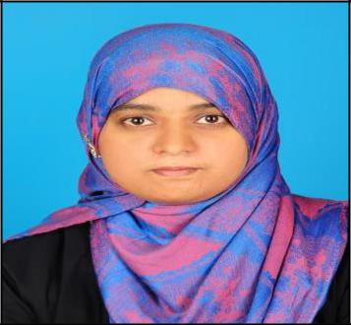
SABIRA
SABIRA.361275@2freemail.com

OBJECTIVE:

Be in challenging Position as Assistant Pharmacist where I can contribute my skill and fast learning capabilities, and be a part of professionally managed organization that provides excellent opportunities and scope for learning and individual development of the organization.

PROFESSIONAL EXPERIENCE:

✓ Alpha Medicals, Nileshwar, Kerala, India

3-Years of experience from June 18th 2013 till August 2nd 2016.

Job Title: Pharmacist.

Task performed:

  - Providing accurate information on the medicines being sold and have a thorough knowledge of product including care instructions.

  - Achieving Maximum Sales potential in line with individual & departmental

  - Handling Pharmacy Software Application.

  - Updating store sales target and sales information on daily & Monthly basis.

  - Ensuring cash operation processes are in line with company standards

  - Ordering for purchase the medicines according to the demand

  - Welcoming and Dealing the Customer according the company Standard Policy.

- P.A Medicals, Kanhangad, Kasargod, Kerala

2-Years of experience from March 9th 2009 to May 18th 2011.

Job Title: Pharmacist.

✓ New Ajanur Medicals ,Kanhangad, Kasargod,Kerala

2-Year of experience From June 20th 2005 to June 6nd 2007

Job Title: Pharmacist.

1

EDUCATIONAL EXPERTISE:

➢ Passed HAAD Examination (UAE) on 20 Dec 2016

EXAM/DEGREE | INSTITUTIONS | UNIVERSITY/BOARD | YEAR OF | STATUS/REG.NO
 |  |  | PASSING
D.PHARM | Malik Deenar College | Directorate of | 2005 | Passed/32056
 | Pharmacy, Kasargod | Medical Education
PLUS TWO | Iqbal Higher | Board of Higher | 2002 | Passed
 | Secondary School, | Secondary
 | Kanchangad, INDIA | Examination Kerala
SSLC | Rajas Higher | Board of General | 2000 | Passed
 | Secondary School, | Education
 | Nileshwar,INDIA | Department of
 |  | Kerala

TECHNICAL QUALIFICATION:

- Microsoft Windows, Microsoft office (Word , Excel, PowerPoint)

- Expertise in Pharma Software Application

PROFESSIONAL MEMBERSHIPS:
- Member of Kerala State Pharmacy Council

- Member of Kerala Private Pharmacists Association

PERSONAL ATTRIBUTES:

Organizational Skill with ability to working under High stress. Understand the effectiveness of teamwork.

Good inter- Personal communication skills. Sincere and Punctual on work

Dedicated, Disciplined, straightforward and honest.

Fast leaner, Hardworking, very sociable and well presented.

2

PERSONAL PROFILE:

Gender | : Female
Nationality | : Indian
Marital Status | : Married
Date of birth | : September 14th 1984
Languages Known | : English, Malayalam, Hindi & Basic Arabic
Hobbies | : Read books, Listening Music

DECLARATION:

I hereby declare that the above furnished details are true to the best of my knowledge.

3

