Resume
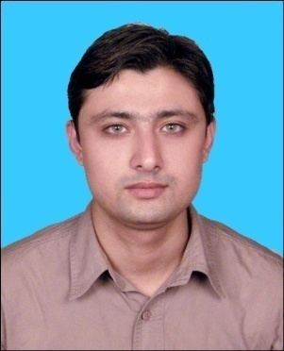

Dr. Taseer
Taseer.361311@2freemail.com

Career Summary:
- Seeking the position of a teacher of Urdu in the organization that will give me the opportunity to utilize my skills set for the progress of the organization.
- Intend to build a career which will help me to explore myself fully & realize my potential.
- To take up a challenging career which offers continue opportunity to move up on the ladder & be the part of a team in achieving the required objectives.

Skills:
- Ability to work with the students of different attitudes and skills.
- Excellent communication and ability to mix with children effortlessly.
- Ability to create an effective teaching method for students.
- Ability to handle the behavior of the students.
- Ability to interact with the students effectively so that they can learn quickly.
- Ability to motivate the students so that they will consider themselves a special personality.

Responsibilities:
- Teaching the students the fundamental skill of the language through various methods of teachings.
- Inspiring the students to learn the new things and by doing so shaping their future according to their interest & interacting with each student and helping him/her to solve their problem.
- Developing the various aspects of the students i.e. physical, emotional, mental and social by allowing them to learn according to their creativity.
- Organizing the students in the groups so that they can interact with each other and by doing so they can develop their personality.
- To complete the given syllabus in time.

Educational Qualification:

S. No. | Exam | M. Marks | M. Obtained | % age | Year | University/State/Country
1 | B. A. Arts | 1650 | 0853 | 51.59 | 2002-2005 | Jammu University (J&K, India)
2 | M. A. Urdu | 1600 | 1047 | 65.43 | 2005-2007 | Jammu University (J&K, India)
3 | B. Ed. | 1000 | 0577 | 57.70 | 2007-2008 | Jammu University (J&K ,India)
4 | M’ Phil Urdu | CGPA 7.00 out of 9.00 |  |  | 2008-1010 | Jawaharlal Nehru University, New Delhi, India
5 | Ph. D. Urdu | Qualified |  |  | 2010-2014 | Jawaharlal Nehru University, New Delhi, India
6 | NET | Qualified |  |  | 2007 | University Grant Commission, New Delhi, India
7 | SET | Qualified |  |  | 2007 | Jammu University, J&K, India

- Two Research Articles published in the magazine with ISBN number.
- One book in Under Publication.
- Having knowledge of computer.
- Language proficiency:
i) Speaking - English, Urdu, Hindi, Kashmiri, Punjabi, Dogri, Hindi.
ii) Writing - English, Urdu, Hindi
iii) Basic knowledge of Arabic.

Abbreviations:
- BA - Bachelor of Arts
- MA - Masters of Arts
- B. Ed. - Masters of Arts
- M’ Phil - Master of Philosophy
- Ph. D. - Doctor of Philosophy
- NET - National Eligibility Test
- SET - State Eligibility Test
- J&K - Jammu and Kashmir

Work Experience
1. Worked as lecturer in Urdu in Various Colleges of Jammu University.
S. No. | Name of the College | Session
1 | Government Degree College Chattroo, Kishtwar, J&K (India) | 2012-2013
2 | Government Degree College Ramban, J&K (India) | 2013-2014
3 | Government Degree College Bhaderwah, J&K (India) | 2014-2015
4 | Government Degree College Bhaderwah, J&K (India) | 2015-2016
5 | Government Degree College Bhaderwah, J&K (India) | 2016-2017

