361312@gulfjobseekers.com
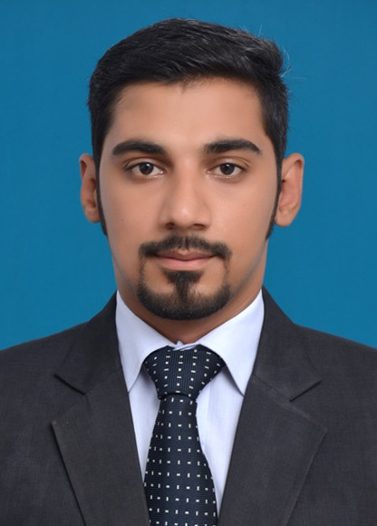

SKILLS

- Hands on experience in Microsoft office Package.
- Administration & Office Management
- Planning, Organizing & Coordinating capabilities.
- Good communication & Multi-tasking
- A team Player with high level of dedication

WORK EXPERIENCE

Blue Light Industry LLC (Trinity Holdings)- Dubai, UAE (Oct-2015- Present )
Key Responsibilities | Admin Coordinator  - Generate & Execute Delivery orders, purchase orders & Invoices.  - Prepare & Handle reports on overall production and dispatch.  - Prepare quotations, receipts & other documents.  - Provide administrative support to the General Manager of Division & Sales department.  - Control the office assets; provide needful support to other departments.  - Maintain Customer sample information & circulate to relevant department.  - Assists HR manager for accomplish HR task & Duties.  - Carrying administrative duties such as filing, typing, copying, scanning, Manage files, record systems, office supplies and inventory etc.  - Prepare correspondence, reports, forms, vouchers and specialized documents related to unit requirement.  - Creating and modifying monthly reports on production and dispatch planning.  - Establish files & distribute all incoming mails/faxes/memos & internal correspondence.
The Initiators-Lhr, Pakistan

Key Responsibilities | Assistant Admin Officer  - Update Trello Boards for coordination, work distribution & Records of all projects  - Conduct market research and analyze data for appropriate outcome and implementation (Surveys & Pilot testing)  - Assist with gathering and summarizing financial information & producing report for project  - Record details of inquiries; maintain office files, complaints and actions taken.  - Other duties as assigned by the project manager to contribute the growth of the department and office

Petro-Tech Energy Solutions-Lhr, Pakistan.

Key Responsibilities | Sales & Marketing Executive  - Cold calling & prospect for new business, Gathering market and customer information  - Writing reports, Analyzing price, demand & competition in market  - Make accurate and rapid cost calculations and provide customers with quotations  - Performing job-related duties as necessary.  - Responsible to Develop & maintain reports
Project Based Experience

 | Noor-E-Ahad-Lhr, Pakistan.
Key Responsibilities |  | Supervisor  - Plan, schedule and set targets for teams  - Hire all the staff required for completion of project  - May arrange for office equipments  - Supervise and coordination with all shift supervisors  - Check all shift reports and set meetings  - Follow all the standards of company policy  - Identify staff development as well as training needs ensures that training is obtained  - Perform other duties as assigned by Project manager

Noor-e-ahad– lhr, pakistan.

Key  Responsibilities | Shift Supervisor  - Maintain clean and organized environment and when necessary  - Assists in distribution of duties  - Establishes positive communication among all team members  - Provide techniques and guidance to enhance their data entry speed and motivate them towards achieving targets  - Allocate targets to teams on daily basis

Noor-e-ahad– lhr, pakistan.

Key  Responsibilities | Data Entry operator  - Sorting, sequencing and entering text based & numerical data  - Achieve assigned targets  - Daily reporting to Shift supervisor

PROFESSIONAL QUALIFICATION

DEGREE | YEAR | INSTITUTE/UNIVERSITY
BBA (Marketing) | 2010-2014 | Superior University Lahore

PROJECTS & ACHIEVEMENTS

- Worked as District Coordinator (RWP) 6th QAT FAS Program of Punjab Education Foundation (PEF).
- Attended 3 days training on a module of CAPM certification by Certified (PMP) Mr. Ahsan project Manger in Warid Telecom.
- Worked as a Field researcher with Sidat Hyder Murshed Associates on a Project of PSDF (Pakistan skills development funds) on Footwear industry of Pakistan.
- Field work of customer satisfaction survey with Startex Marketing services as well as Oasis Insights.
- Worked as Steward in Punjab Youth festival 2014 and 2015.
- Organized CEO forums in superior university.
- Certificate of participation in Brand activation of “Daily Nai Baat” as a team leader.
- Team leader in the 6th QAT FAS Program of Punjab Education Foundation (PEF).
- Attended a four days training on “Social action project” by Mr. Baber at Superior University Lahore. A project by British Council and Channan Development Association, Initiated welfare organization named as AASRA Welfare Foundation.
- Position Holder in 1st, 3rd, 5th, 6th semester during Bachelors.

LANGUAGES KNOWN

- Fluent in ENGLISH speaking, reading & writing.
- Fluent in URDU speaking, reading & writing.
- Fluent in PUNJABI speaking, reading & writing.

