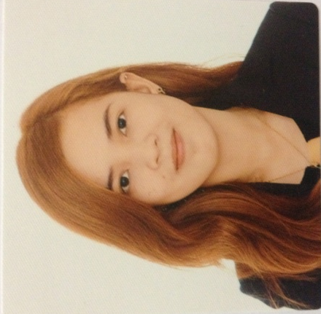
VERONICA
VERONICA.361327@2freemail.com

CAREER OBJECTIVE
To be part of company that will provide more challenging and rewarding career that could enhance my analytical skills through working experience and allow professional advancement and fulfillment. To find a fulfilling careers based on my skills through experienced.

WORK EXPERIENCE:

September 2016- February 2017, Municipality of San Mateo
SECRETARY

- Typing, preparing and collating reports.
- Filing.
- Maintaining diaries and arranging appointments.
- Answering calls, taking messages and handling correspondence.
- Logging bills and expenses.
- Organizing and servicing meetings.

- managerial duties as day to day operation require, and responsible to take care the
- shop if the manager is not arou
February 2016-August 2016, Philippine Batteries, Incorporated
HR ASSISTANT

- Assisting and accommodating employees concerns.
- Responsible for answering and transferring phone calls.
- Identification of training needs and organizing training programs
- Filing, Encoding files.
- Organizing company’s events and activities.
- Managing all materials/office supplies.
- Compiling reports which includes summarizing of weekly security reports and employee violations towards the company rules and regulations.
- Issuing employees’ salary certificates, sick leave, and other employee forms.
- Handling employees’ confidential documents.
- Photocopying, printing, and scanning employees’ files and other supporting documents.
- Monitor tracked emails and check couriers.
- Announce appointments and meetings through online communication.
- Updating employee attendance and violations.
- Perform other HR related task.

June 2015 – December 2015, McDonald’s- San Jose, Nueva Ecija, Philippines
CASHIER

- Counting money in the drawers at the end of the working period.
- Take an order, input it into the computer, receive payment from a customer and give out change as required.
- Giving reports and ensuring accuracy of all transactions.
- Entering the kitchen to collect food that have been prepared and organized either as take-away or on a tray for dine-in customers.
- Verifying register receipts of daily transactions.

QUALIFICATIONS
- Ability to work under pressure
- Ability to listen and communicate effectively
- Microsoft Office skills, Powerpoint, and Excel
- People-oriented and Flexible
- Clerical and administrative skills
- HR knowledge
- Self-motivation and ability to take the initiative
- Punctuality and time-keeping

EDUCATIONAL Central Luzon State University
BACKGROUND Bachelor of Science in Business Administration major in Human
Resource Development Management
June 2012 – July 2016

