Mustafa
Mustafa.361329@2freemail.com
Objective

Seeking a challenging position in a fast-growing organization where my enthusiasm, experience and skills could be exploited to achieve personal as well as organizational goals and objectives with a good knowledge in Sales executive, office services Management “Archiving Administrator “, Logistic Services “Transportation” and events management.

Key Skills

- Self-motivated
- Confident
- Fast learner
- Time Management
- Excellent communication skills, Team work
- Negotiation skills
- Ability to work individually and collectively.

Experience
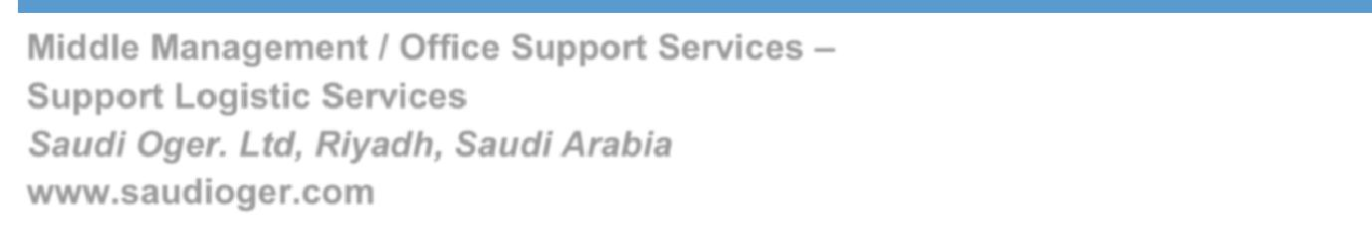

Middle Management / Office Support Services – Support Logistic Services

Saudi Oger. Ltd, Riyadh, Saudi Arabia

www.saudioger.com

(Dec 2011 – Present)
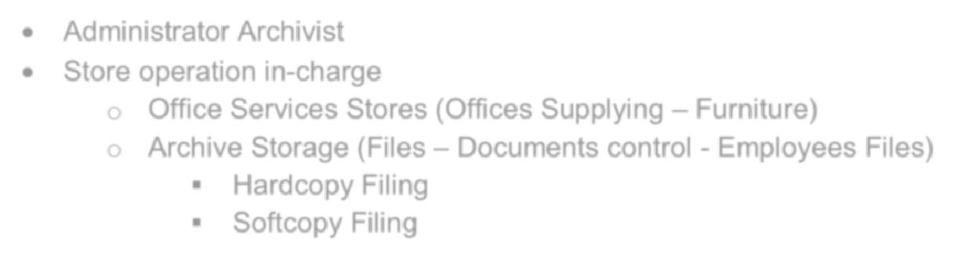

- Administrator Archivist

- Store operation in-charge

- Office Services Stores (Offices Supplying – Furniture)

- Archive Storage (Files – Documents control - Employees Files)
  - Hardcopy Filing

  - Softcopy Filing

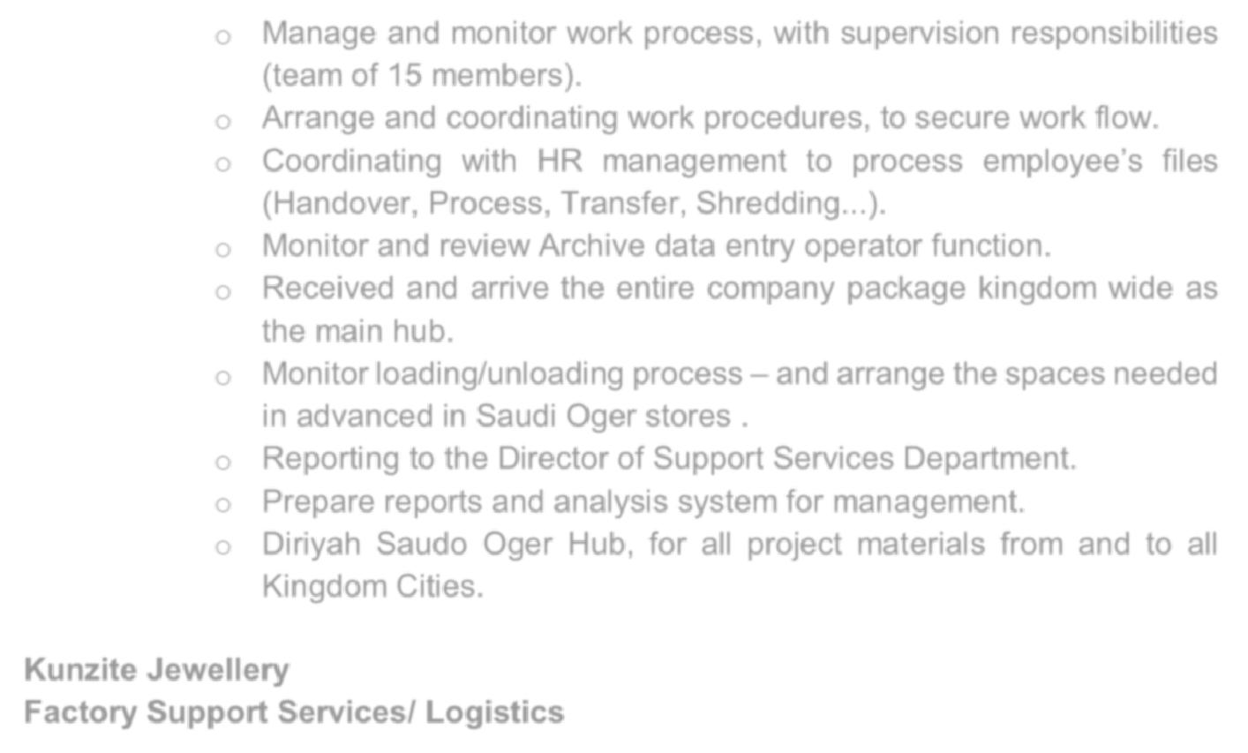
- Manage and monitor work process, with supervision responsibilities (team of 15 members).

- Arrange and coordinating work procedures, to secure work flow.

- Coordinating with HR management to process employee’s files

- Monitor and review Archive data entry operator function.

- Received and arrive the entire company package kingdom wide as the main hub.

- Monitor loading/unloading process – and arrange the spaces needed in advanced in Saudi Oger stores .

- Reporting to the Director of Support Services Department. o Prepare reports and analysis system for management.

o Diriyah Saudo Oger Hub, for all project materials from and to allKingdom Cities.

Kunzite Jewellery

Factory Support Services/ Logistics

(Oct 2015 – Jan 2017)
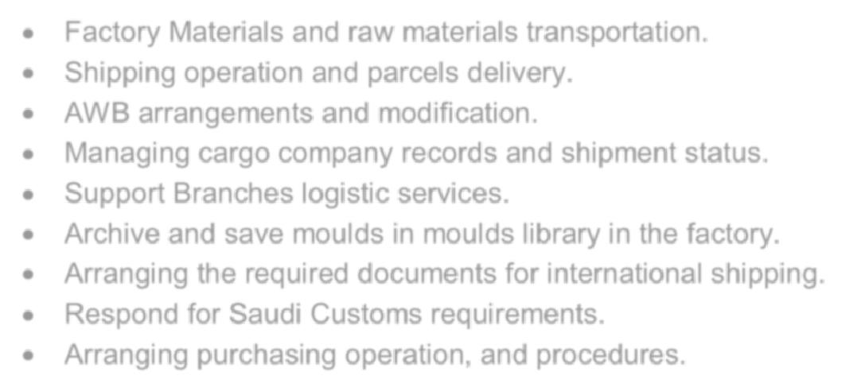

- Factory Materials and raw materials transportation.

- Shipping operation and parcels delivery.

- AWB arrangements and modification.

- Managing cargo company records and shipment status.

- Support Branches logistic services.

- Archive and save moulds in moulds library in the factory.

- Arranging the required documents for international shipping.

- Respond for Saudi Customs requirements.

- Arranging purchasing operation, and procedures.

(Free Lancer)
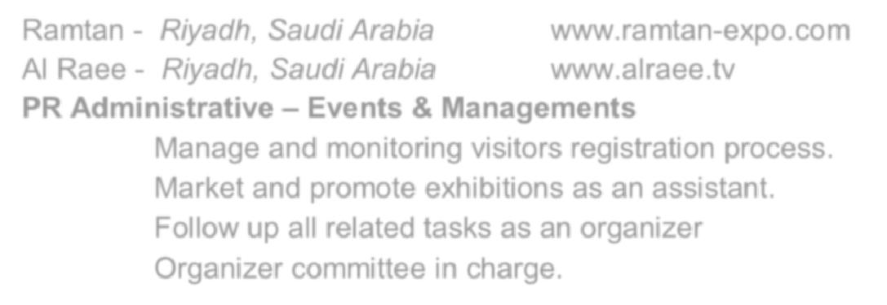

Ramtan - Riyadh, Saudi Arabia www.ramtan-expo.com

Al Raee - Riyadh, Saudi Arabia www.alraee.tv

- Manage and monitoring visitors registration process.

- Market and promote exhibitions as an assistant.

- Follow up all related tasks as an organizer

- Organizer committee in charge.

Education

College/School

2015/2016

Diploma in Business Administration Institute of Commercial Management

School Name

June 2011 High School Certificate

Noor Al Maaref International School, Riyadh–Saudi Arabia

Courses
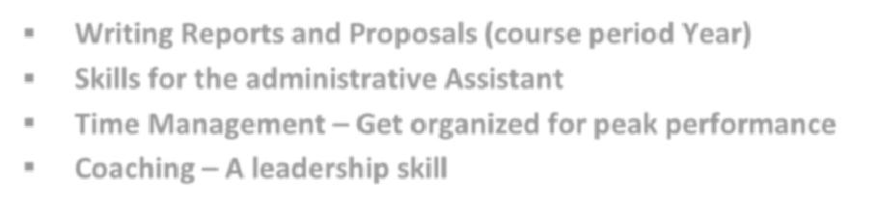
- Writing Reports and Proposals (course period Year)

- Skills for the administrative Assistant

- Time Management – Get organized for peak performance

- Coaching – A leadership skill

Languages
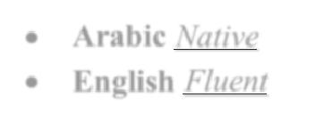

- Arabic Native

- English Fluent

Technical Skills

- Computer (Ms Office Suite) & Internet
- Ability to handle software

- Windows Vista / XP/Windows 7-8

Hobbies & Interests

- Computer and internet
- Researches
- Playing Football
- Swimming

- Cycling

References

References are available upon request.

