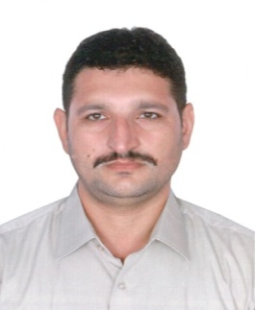Visa Status - Visit / Transferable

CURRICULUM VITAE

ALAMGIR
ALAMGIR.361333@2freemail.com

Career Objective:

To work with a dynamic, team oriented competitive and co-operative environment in a reputable organization, where there is maximum chance of learning and grow as a professional, innovative and committed person with organization's policies.

Qualification:

- D.A.E Electrical (Diploma of Associate Engineering) 3 years.
Govt College Of Technology Peshawar

- Two Years Of Vocational Course
Govt Vocational Institute Ekka Ghund

- Matriculation (Science)
Board of intermediate &Secondary Education Peshawar
Skills:

- Strong presentation and communication skills.

- Strong interpersonal skills.

- Can handle critical situation and bear the work pressure.

- Microsoft Word.

- Microsoft Excel.

- Microsoft power point.

- Internet.

Practical Experience :

- Worked with stratum owner association from Aug-2015 to Dec-2016 as a facilities engineer for(08) buildings in (DSO Dubai) to communicate with service provider to keep all buildings hard & soft Services to well maintained building with all facilities
- Monitoring of all mechanical/electrical/civil/plumbing works
- In case of any incident taking action on emergency basis
- Preparation of incident reports
- Preparation of daily & monthly reports
- Regular follow up for pending works
- Worked as a Electrical Supervisor InCirta Electro Mechanical & Maintenance
of electrical work all army camps Abu Dhabi and Northern region From
(1/11/2013) Upto (!5/3.2015)

- Maintenance of all MEP Work

- Installation of Street Lights GI Poles and cable lying

- Installation of LCP (Light control panel)

- Installation of PVC pipes for Wiring in slabs of villas

- Installation of Wiring in villas to all electrical points

- Installation of MDB’S, SMDB’S and its termination

- Worked With Pakistan Islamia Higher Secondary School Sharjah As a
Maintenance EngineerFrom (9/9/2010) Upto (10/9/2013)

- To Control All The Electric Problems And Its Solution
- Look After Over All Maintenance Of Building
- Installation Of New Power Distribution Boards
- Maintenance Of Fire Alarm System
- Also Utility Officer
- Cable Laying For CCTV Cameras
- Installation Of Water Pumps & Its Electrical Termination
- Also Attend Several Function As a Sound System Controller

- Worked With Admak Alkharafi (Abudhabi) As Electrical Foreman

From (11/6/2008) Upto (12/6/2010)

- Daily planning and achievement.

- Main power distribution and overtime control

- Cable glandding and termination.

- Power, lighting DB dressing.

I hereby certify that all details given are true to the best of my knowledge.
If given a chance assure you that I will my level best to brainy out positive results.
This will be satisfactory to the company it’s concerned.

