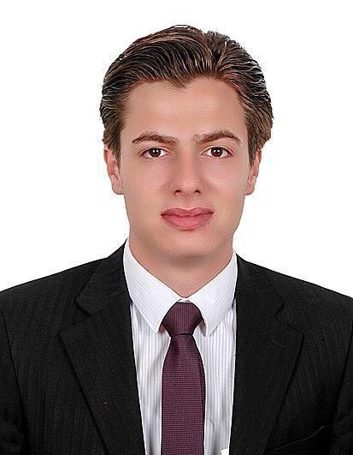

Mohamad
Mohamad.361361@2freemail.com

Objective:

To join a well-established organization where I can utilize my experience for the progress of the company, looking for stability and longtime workmanship.

Academic qualification

[2014] | Kalamoon University | Der Atiye, Damascus, Syria
Bachelor degree in Pharmacy and Medicinal Chemistry
Graduation Project: "Determination of Serum Magnesium in Diabetic Patients"
[2007] | High School Education | Homs, Syria
Syrian baccalaureate certificate for finishing the high school education, scientific branch from the Directorate of Education, Homs, Syria

Languages

Arabic | :Mother Tongue
English | :Good (speaking & writing)
 | National exam for attending the master degree (PBT
 | TOEFL test), A.L.T.C. Institute, Damascus, Syria
German | :Beginner (speaking & writing)
 | Beginner principles in the German language – Higher
 | Institute for Linguistics, Al-Baath University, Homs,
 | Syria

Experience

[2008 – 2010] Al-Saad medical drug store Homs, Syria

- Ability to marketing and sales and the collection of customer
- The ability to open new markets and management team work

- The ability to follow the client permanently

- Supervision of the warehouse and the follow-up mechanism of action

[2010 – 2014] Lama Pharmacy Homs, Syria

During my study, I worked as a part time in Lama Pharmacy, Homs, which is owned by my family. I was doing the daily duties of a pharmacist assistant, serving the customers, taking care of the pharmacy, preparing the drugs orders and performing daily financial issues.

[ April.2014- Sep.2016] Lama Pharmacy Homs, Syria

Responsible for the day to day running of the Pharmacy. Providing a professional sympathetic and supportive service to patients and identifying the right healthcare solution to meet their needs.

- Accurately dispensing drugs to patients according to a doctors prescription.

- Checking prescriptions for errors & making sure they are appropriate for patients.

- Measuring, packaging, labeling and recording medications issued to patients.

- Instructing patients on how to use medications, possible side effects and storage.
- Contacting and working closely with other healthcare professionals.

- Answering questions from patients and staff about medicines.

- Ensuring the accuracy of all prescriptions, products and services supplied.

- Helping to develop the pharmacy's electronic discharge system.
- Managing and resolving complaints.
- Talking to regular patients to see how their treatment is going.

- Able to trains and supervise Pharmacy Assistants.
- Communicating with customers sympathetically and supportively.

- Giving private consultations when required.

- Maintaining pharmaceutical stock, creating inventories and ordering more drugs.

[Oct.2016 – Present] Dr. Nutrition center Dubai, U.A.E

- Respond to incoming sales calls
- Handled costumer service for designated territory

- Followed up on leads

- Sought referrals

- Directed sales field and expanded its customer-base – Developed, maintained and expanded business with current/new customers.

Skills, Strengths & Attributes

- Proficient in using PCs.

- High skills in internet & e-mail.

- Very good skills in using MS Office.

- Very good skills in sales.
- Very good skills in negotiation, communication & time management. I joined several

training courses and workshops regarding interpersonal and communication skills in the Skills & Career Center at Kalamoon University.
- Ability to work in a busy high stress environment under deadlines and the ability to manage day by day duties independently.

- Extremely quick to learn with excellent relation capabilities.

All documents and certificates are available upon request.

