Ansari
Ansari.361391@2freemail.com
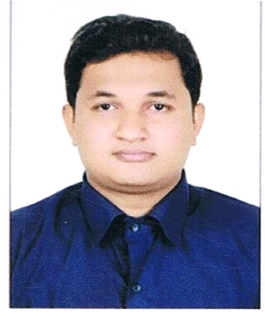

Looking for a successful, challenging, exiciting career in pharmacy while dispensing maximum potential to benefit to the organization that provides an opportunity in order to keep abreast with latest trends and technologies, at the same time complimenting my passion for learning.
As a pharmacist I believe in proven programmatic solution to optimize the ward and patient satisfaction, as well as the quality and efficiency of the hospital / hospital pharmacy.

- Strong communication skills
- Team Player
- Expertise in Pharmacy inventory, Billing, and over all data
- Patient counseling
- Willingness to Learn
- Strong Interpersonal Skills
- Clinical Pharmacists

Academic Credentials
DHA Qualified
Master of pharmacy from University of Pune in 2015 with First class
Bachelor of pharmacy from University of Pune in 2013 with Higher second class
Diploma in pharmacy from Maharashtra board (MSBTE) in 2010 First class
XII from Maharashtra State Board, India in 2008 with First class
X from Maharashtra State Board, India in 2006 with Second Class

Computer Skills

- Operating Systems: Windows.
- Tools: MS Excel, MS Word, MS PowerPoint.

Professional Experience

INAMDAR MULTI SPECIALITY HOSPITAL PUNE:
- Clinical Pharmacist from 1st August 2013 to April 2014.

RAHEL MEDICAL AND GENERAL STORES:
- Pharmacist’s at Rahel Medical & General Store, Camp Pune, from 1st June 2013 Till 31st March 2017.

ACHIVEMENTS

- Promotion from assistance pharmacist to Pharmacist In-Charge.

Miscellaneous

- Active interests in Cricket and Fitness & Health training
- I am fond of making new friends and developing new contacts.

