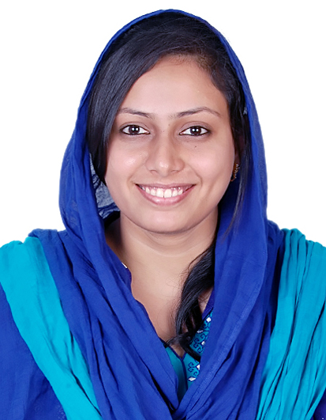

**Dr.Saniya**

[**Saniya.361402@2freemail.com**](mailto:Saniya.361402@2freemail.com)

**Work Experience**

|  |  |  |  |
| --- | --- | --- | --- |
| Serial No | Place | Duration | Position |
| 1. | Dr. Kamakshi Memorial  Hospital | May 2015 – May 2016 | Specialist and General Dentist |
| 2. | Evershine Dental Clinic | Dec 2014 - Sep 2016 | Specialist |
| 3. | PGIMER Chandigarh | July 2011 - Dec 2014 | Dental Resident |
| 4. | Asif Baig Dental Clinic | Nov 2009 – June 2011 | GP Dentist |

**Academic qualifications**

|  |  |  |  |
| --- | --- | --- | --- |
| S.No | Degree | Duration | Institute |
| 1 | MDS Pedodontics | 2011-2014 | PGIMER Chandigarh |
| 2 | BDS | 2004-2009 | Saveetha Dental college, Chennai |
| 3 | House Job | 2010-2011 | PGIMER Chandigarh |

**Accreditations & Licenses**

* **Dubai Health Authority Licensing Exam as General Dentist – December 2016**
* **Have applied for MOH license in February 2017**
*  Tamil Nadu Dental Council Registration, Good standing certificate
*  Indian Dental Association Member

**Awards and Special Recognitions**

1) Best outgoing student – Gold Medalist in Final Year of BDS (2008)

2) Best Paper Award – Basic Medical Sciences Conference in Saveetha University 2004 – ‘Decoding the Chemistry behind Alzheimer’s Disease’

3) Nationwide ISPPD quiz winner in Students Quiz in 35th ISPPD Conference 2013 in Jaipur, Rajasthan

4)Good Shepherd Rolling Shield Awardee for highest marks in biology in 12th Board exams

**Skills specialized in**

**Pediatric Procedures**

1. Examination of children and diagnosis of dental diseases along with interpretation of radiographs
2. Endodontic treatment in primary teeth including Stainless steel crowns and Strip crowns
3. Removable orthodontic appliances including delivery of Face Mask, Head Gear and Jaw trainers
4. Construction of space maintainers and habit breaking appliances and cap splints
5. Construction of Custom made Mouth Guards for contact sports and Oral Splints for Bruxism
6. Minor oral surgical procedures including frenectomy, excision of mucocele, fibroma
7. Preventive Dental procedures including Fluoride application, Pit and Fissure Sealants
8. Management of traumatic dental injuries including avulsed/fractured teeth
9. Treatment of patients under Sedation and General anesthesia

**Adult Procedures**

1. Experienced in interpreting specialized radiographs like Digital radiographs, OPG and Cephalograms
2. Restoration of fractured/carious tooth with materials like composites, ionomers etc.
3. Performance of premolar/molar RCT including restoration using Fiber Reinforced Post and core
4. Crown and Bridge preparation for PFM and all ceramic crowns
5. Construction of Partial and Complete Dentures
6. Dental veneer construction, bleaching and other esthetic dental procedures
7. Extraction of wisdom teeth
8. Curettage, operculectomy, excision of gingival growths and management of pregnancy/hormonal induced gingival enlargement

**Personal Details**

**Languages spoken: English, Hindi, Punjabi,Urdu, Tamil,Basic Arabic**

Nationality: Indian

**Research activities**

1) Mariam Goyal A,Gauba K - Risk Factors for Molar Incisor Hypomineralization

in 8-12 year, old school going children in Chandigarh. Post Graduate Thesis

**Areas of Special Interest:**

* Management of mutilated dentition
* Pediatric and Adult Endodontics
* Management of Traumatic Dental injuries
* Habit breaking appliances
* Esthetic dental procedures

**Paper and poster presentations:**

1. Scientific Paper Presentation – ‘Risk Factors for MIH’ at 36th Annual Conference

of ISPPD 2014 in Lucknow, Uttar Pradesh

2. Scientific Poster presentation – ‘CBCT-An emerging solution to a precise

diagnosis’ at 35th Annual Conference of ISPPD 2013 in Jaipur, Rajasthan

3. Scientific Poster presentation – ‘Mobius Syndrome- Dental and Orofacial

manifestations’ at 34th Annual Conference of ISPPD 2011 in Mangalore Karnataka