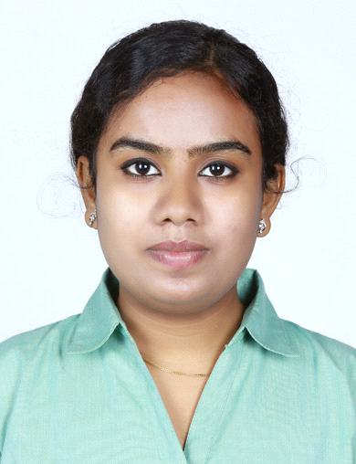Sneha
Sneha.361421@2freemail.com
CAREER OBJECTIVES

Preferably looking for a HR role within a reputed firm with the approach to take up responsibilities to accomplish organizational goals wherein my skills and potentials are being utilized to the maximum; alongside focusing on the scope of enhancing my personal skills & gaining maximum knowledge during my tenure to contribute to the growth of the firm.

PROFESSIONAL PROFILE

Assistant HR at Q5soft from January 25, 2016 January 31, 2017.
Key Responsibilities handled as AssiatantHR :
- Recruiting candidates in assistance of HR Manager.
- Interacting and Tie up with Consultancy’s for recruiting Candidates.
- Scheduling interviews.
- Scheduling training programmes& Induction.
- Maintaining Data in spreadsheets related to Organization.
- Maintained existing accounts and ensured proper record keeping.
- Handling incoming and outgoing calls.
- Maintaining Employee details in Database.
- Maintaining Employee attendance and send to payroll department by the end of month.
- To plan, organize, and administer the activities of the department, office, or division efficiently. Prepare reports and presentations.
- Preparing Relevant Documents like Offer Letter,Relieving Letter.
- Appraisal based on perfomance in assistance of HR manager.
- Maintaining a good work culture and employee relations.
Process Associate at RR Donnelley (KPO) From July 11, 2013 to January 17, 2016
Key Responsibilities handled as a Process Associate.
- Responsible for the activities of the team as a team lead.
- Allocating work to the team menbers.
- Conducting Team meetings.
- Ensuring whether the work is completed as per the SLA.
- Processing the Accounts of a leading water company in UK within the time frame for each day and by meeting the SLA.
- Managing and processing Customers account (Domestic/ commercial).
- Providing a new connection to billing and further recovering the debt, all the related back end procedures.
- Giving training to the new bees related to my process as a core agent.
- Maintaining unity, healthy competition, friendly environment, and good culture in my team.
- Sceduling entertainment programmes as per the convenience of all the teams.

Achievements
- Top production rewards in R&R ceremony.
- Best team lead reward in R&R ceremony.
- 1st Runner up and 2nd Runner up in NATANA Group Dance Competition held in Technopark, Trivandrum in 2014 and 2015 respectively.
- Actively participated in different cultural activities, competitions held in office during celebrations& festivals.
- As a member of WON committee participated in social welfare activities held on behalf of RR Donnelley.

ACADEMIC CREDENTIALS

- Pursuing MBA under ICFAI University in distant education program.
- BBM from SadhguruSainath College, Banglore under Banglore University.
- HSC in Commerce group from New Arts Science and Commerce College Ahmed Nagar, Under Pune University.
- S.S.L.C from Auxilium Convent High School, Ahmed Nagar Under Pune University.

Achievements
- BBM department topper 2013.
- 1st prize in college level Bharathanatyam competitions.
- Prizes in school level Dance competitions.
- Prizes in school level group song competitions.

TECHNICAL SKILLS
Operating Systems:
Window Xp& Window 7
Packages:
MS Office (Word, Excel,PowerPoint,
Outlook)
Software & System:
SAP, CRP&CRM.

PERSONAL DOSSIER

Date of Birth : 01.09.1992
Nationality : Indian
Marital Status : Married
Hobbies : Passionate about Dance, Drawing, Listening to music.
Languages known : English, Hindi, Malayalam, Marathi, Tamil, Kannada(Managable)

Personal Qualities:
- Ability to work in any environment.
- Adaptable and Hardworking nature.
- Strong communication skills.
- Effective leadership skills.
- Interact with people in a friendly manner.

DECLARATION
I hereby declare that all the information given above is true and reliable to my best knowledge.

