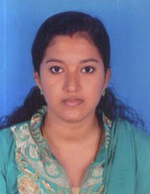
Amrutha
Amrutha.361430@2freemail.com

POST APPLIED: ACCOUNTS

PROFILE
A Suitable position with an organization where I can utilize the best of my skills and abilities that fit to my education, skills and experience a place where an encourage and permitted to be an active participant as well vital contribute on development of the company.

EDUCATIONAL QUALIFICATION

- Secondary School Leaving Certificate
- Higher Secondary Certificate
- B.Com
COMPUTER QUALIFICATION

- Tally
- DCA
work experience

- Company : Medicity Hospital, Kerala India
- Position : cashier
- Period : 1 Year and 7 months

languages known

- English, Hindi & Malayalam

declaration
Here I am kindly declared that the above mentioned details all are true in the best of my knowledge and believe.

