GABRIEL
Email: GABRIEL.361447@2freemail.com
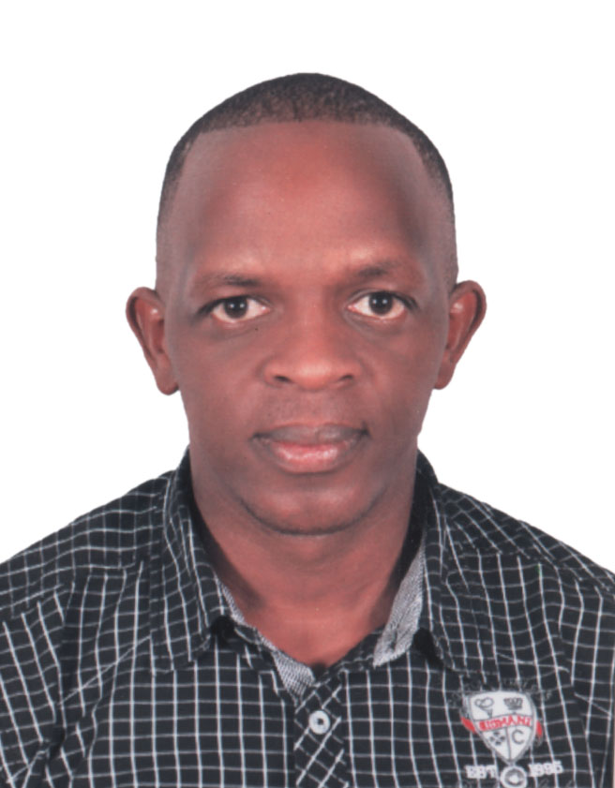

PERSONAL DETAILS
Date of Birth : 3rd December 1983
Gender : Male
Nationality : Kenyan
Marital Status : Married
Religion : Christian
He
H
Visa status : Visit Visa
Languages : English, Kiswahili and Arabic

CAREER OBJECTIVE
To work in an organization where I will be able to put into practice my professional skills for the growth of the organization, make it a better place than I found it.

PERSONAL ATTRIBUTES
To use my professional knowledge to contribute positively to the development of the society, institutions and my employer through advancement in knowledge and hunger to learn and willingness to share knowledge with others and gain useful professional experience to develop my career objectively.

EDUCATION BACKGROUND

2017 Unique College
Certificate in Computer Packages

2004 Turkey Driving School
Driving Class BCE

2002 Mariko Secondary School
Kenya Certificate of Secondary Education

1998 Ndoroto Primary School
Kenya Certificate of Primary Education

WORKING EXPERIENCE
2012-2016 Al Marai, Saudi Arabia
Position: Sales Representative
Duties and Responsibilities
- Source and develop client referrals
- Prepare sales action plans and strategies
- Schedule sales activity
- Develop and maintain a customer database
- Develop and maintain sales and promotional materials
- Plan and conduct direct marketing activities
- Make sales calls to new and existing clients
- Develop and make presentations of company products and services to current and potential clients
- Negotiate with clients
- Develop sales proposals
- Prepare and present sales contracts
- Conduct product training
- Maintain sales activity records and prepare sales reports
- Respond to sales inquiries and concerns by phone, electronically or in person
- Ensure customer service satisfaction and good client relationships
follow up on sales activity

2005-2010 Brookside Dairy Firm
Position: Sales Representative
Duties and Responsibilities
- Maintain sales activity records and prepare sales reports
- Respond to sales inquiries and concerns by phone, electronically or in person
- Ensure customer service satisfaction and good client relationships
follow up on sales activity
- Perform quality checks on product and service delivery
- Monitor and report on sales activities and follow up for management
- Carry out market research and surveys
- Participate in sales events
- Monitor competitors, market conditions and product development
- Generate and qualify leads
- Source and develop client referrals

HOBBIES
Travelling
Socializing
Making new friends
Listening to music

REFEREES

Up on request

