CURRICULAM VITAE
SARVATHULLAh
SARVATHULLAh.361474@2freemail.com 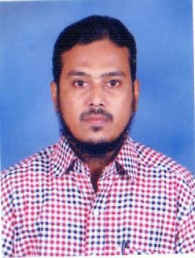

Objective

Seeking to work in a professionally competent workplace that encouraging professionalism and will use my skills and knowledge to ensure proper administration of Windows Systems.

Employment History

OCTOBER 1999 – Present: OFFICE ADMINISTRATOR

MUSLIM HIGHER SECONDARY SCHOOL – Chennai

Responsibilities:
- School students data management
- Generating & Maintaining employees salary records
- In co-operation with Management and Government officials.
- Provide daily support to the Management & Administration.
- Maintaining staff pay role.
- Yearly account closure of GPF
- School administrative maintenance.

Computer Skills

- Software

- MS Office
- Governments Protocol’s & websites
- Photoshop
- C Language

Educational Qualification

EDUCATION | NAME OF THE INSTITUTE | YEAR OF PASSING | OBTAINED MARKS IN %
SSLC | Islamic Higher Sec School – Visharam | 1992-1993 | 67
Diploma in Electrical & Electronic Engineering | Sri Venkateswara Polytechnic | 1993 – 1997 | 60
H.S.S.E | Private | 2003 – 2004 | 56
B.Sc. (IT) | Annamalai University, Chidambaram | 2006 – 2008 | 70
B.A (English) | Annamalai University, Chidambaram | 2010 – 2011 | 45
M.A (English) | Annamalai University, Chidambaram | 2011 – 2012 | 40
M.C.A | Annamalai University, Chidambaram | 2012 - 2014 | 70
Advanced Diploma Embedded System | Certified Course | Sep - 2015 | NA

Personal Profile
Date of Birth : 30/08/1977
Sex : Male
Marital Status : Married
Nationality : Indian
Religion : Islam
Languages known : English, Hindi, Urdu and Tamil.

Passport Details
Date of Issue: 04.07.2013
Date of Expiry: 03.07.2023
Place of Issue: Chennai

Declaration

I hereby declare that the above information furnished is true to the best of my knowledge.

