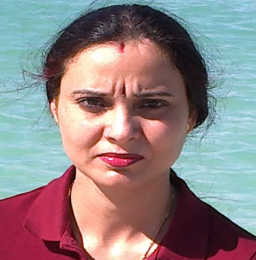

Dr. Kiranjeet
Bur Dubai (UAE)
Email id: kiranjeet.361515@2freemail.com

To,
Manager HRD
Respected Sir/Madam,
Subject: Application for the Medical Officer
Myself Kiranjeet having more than four year experience as a medical officer in NRHM. At present I am in Dubai on husband visa. With reference to your reliable source, I would like to offer my candidature for the post of Insurance consultants. I am able to respond empathetically for this post and enjoying my role in maintaining a positive and productive corporate environment, I would very much appreciate if your organization will give me a chance to serve in your esteemed organization. I am enclosing herewith my curriculum vitae covering all personal information with regard to my qualification and experience, for your perusal. I am sure that my competence and experience will assure you about my ability to serve you the entire satisfaction of your management. Let me have an opportunity to prove myself. Looking forward for bright and challenging career with your hospital.
Thanking You,
Yours faithfully,

Encl: (1) Curriculum Vitae. ( Kiranjeet)

Continue………..

CAREER OBJECTIVE:-
To be associated with a dynamic organization which will help in the overall development of my personality & to create a chance to prove my capabilities and thereby create a niche for myself in the organization through hard work & loyalty.
Personal Information:-
Nationality Indian
Religion Sikh
Marital Status Married
Date of Birth 29th April, 1980
Date of Issue 20 November 2013
Date of Expiry 19 November 2023
Place of Issue Srinagar (J&K)

Professional Experience:-

JOB PROFILE:-
- Upon arrival of patients, examination, physical condition and history taking
- Ordered investigation according to patients need
- Treated patients with acute poisoning
- Managed Critically ill patients in the emergency department
- Studied the pathological reports (X-ray, ECG) and Diagnosis of the diseases and prescribed accordingly.
- Regularly monitored of indoor and outdoor patients and treated them accordingly
- Implemented national immunization programs including Polio and various government health promotional camps.
- Responsible for day by day administration work.
- Front and representative in handling Patients.
- Assist in guiding and addressing/ directing the designation people, in all basic questing of new technologies.
- Providing training to junior medical staff.

_________________________________________________________________________

EDUCATIONAL QUALIFICATION:-
- 10+2 from Jammu and Kashmir Board.
- Bachelor of Unani Medicine and Surgery (BUMS) from Institute of Asian Medical Science Srinagar.
- CPC Certification from (Dubai) UAE, Approved by DHA.

Date: - 20/03/2017
Place: - Dubai

Kiranjeet
(Signature)

